August 4, 2013
By: Matt West
http://bostonherald.com/photos/access_sport_america_camp

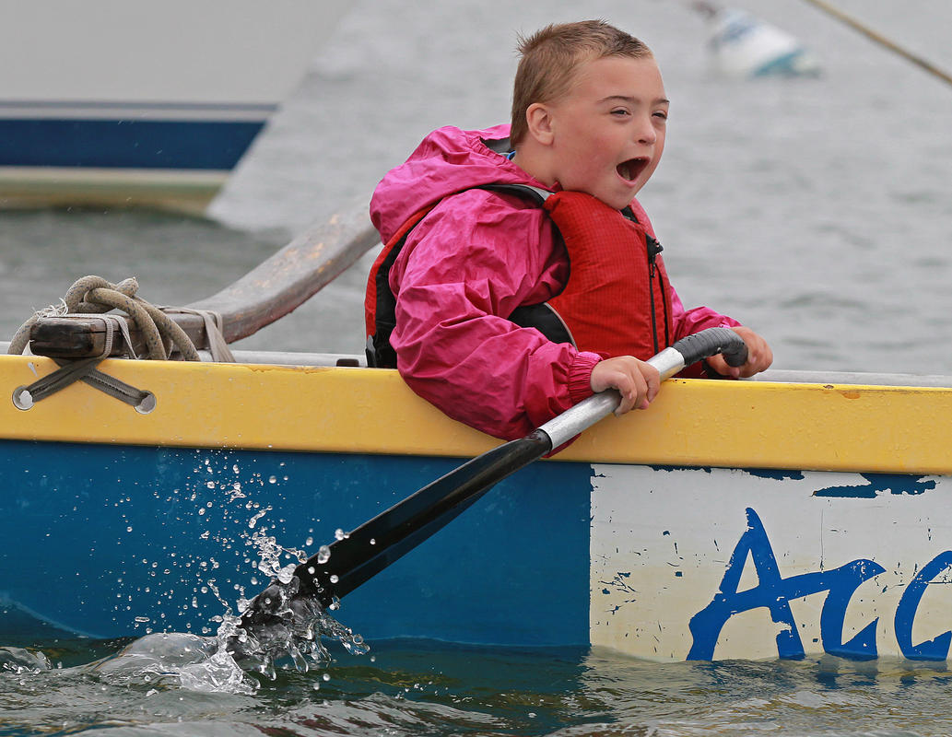

Stephen Fassnacht has a blast paddling on an outrigger canoe at a weeklong camp through Access Sport America

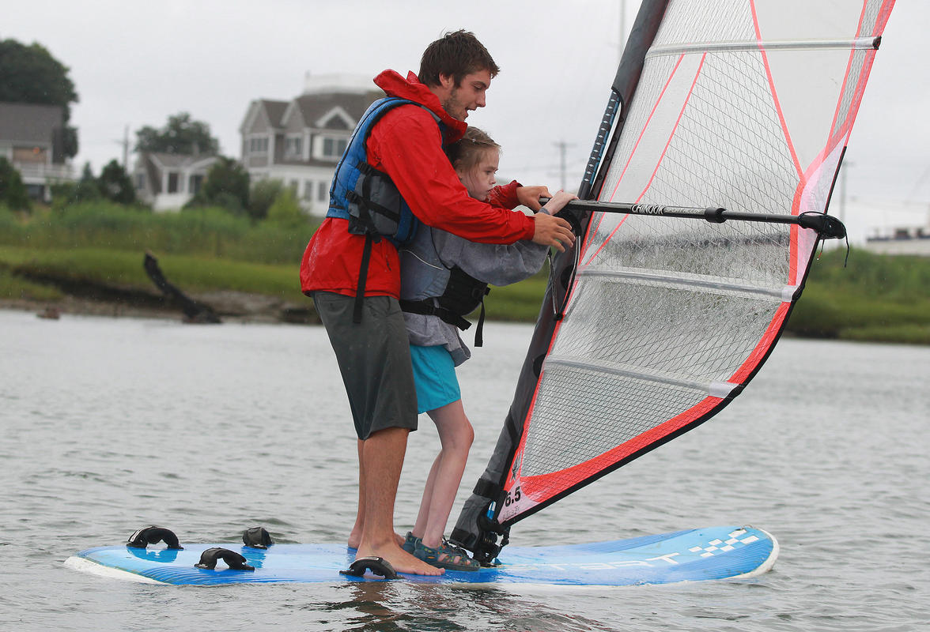
Access Sport America staffer Connor Shea windsurfs with Karly Erickson at a weeklong camp through Access Sport America.

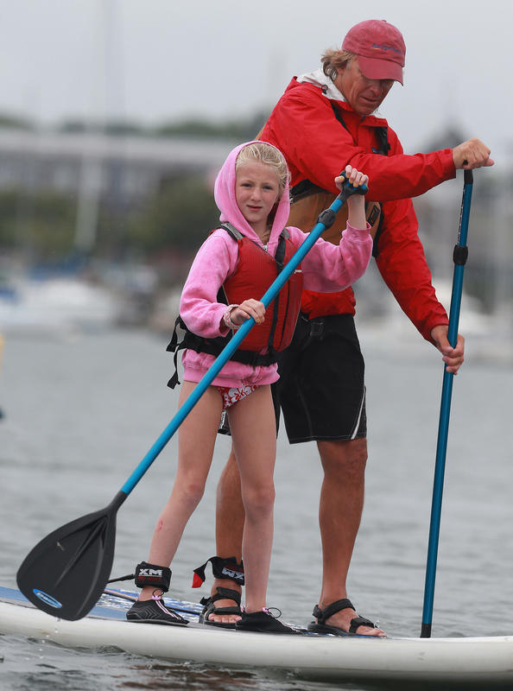
Katie Jurgel stand-up paddles with Access Sport America founder Ross Lilley at a weeklong camp through Access Sport America.

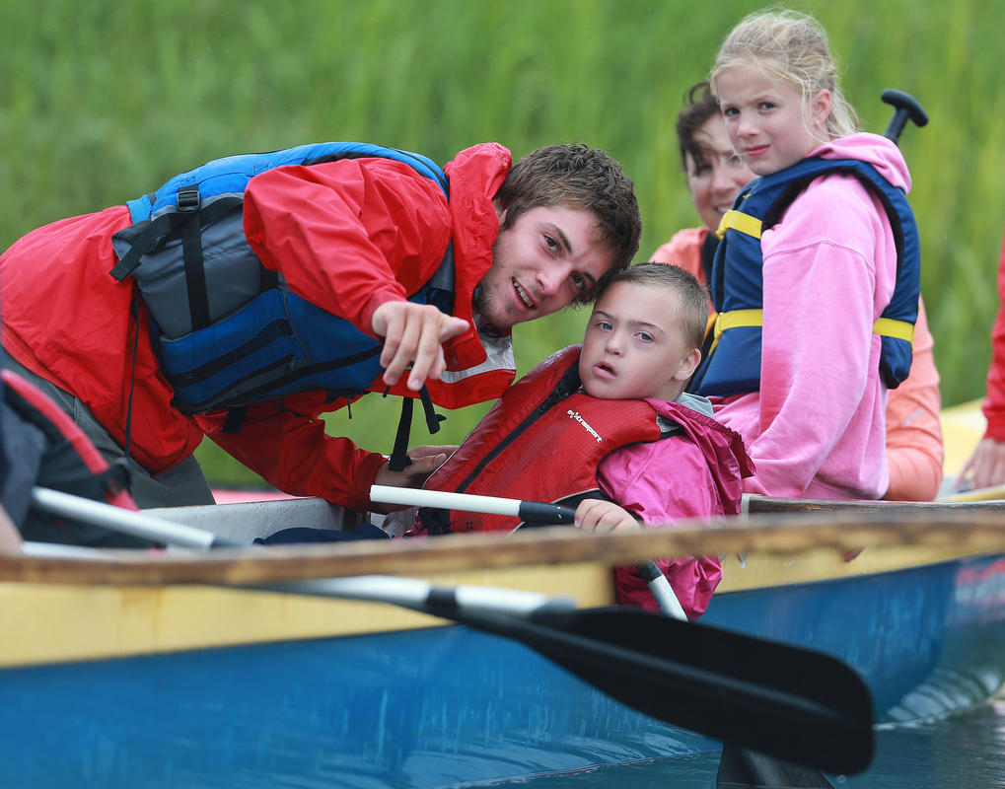
o By: Matt West
Connor Shea of Access Sport America works with Stephen Fassnacht and Katie Jurgel as volunteer Jane McGovern looks at a weeklong camp through Access Sport America.

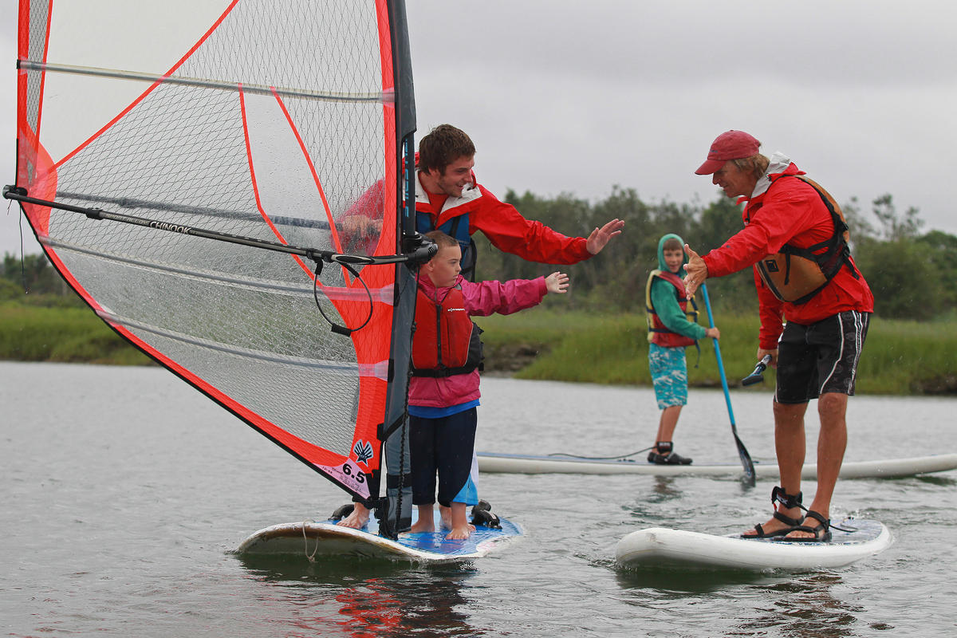

Stephen Fassnacht, left, gets a high five from Access Sport America founder Ross Lilley as he windsurfs with staffer Connor Shea.

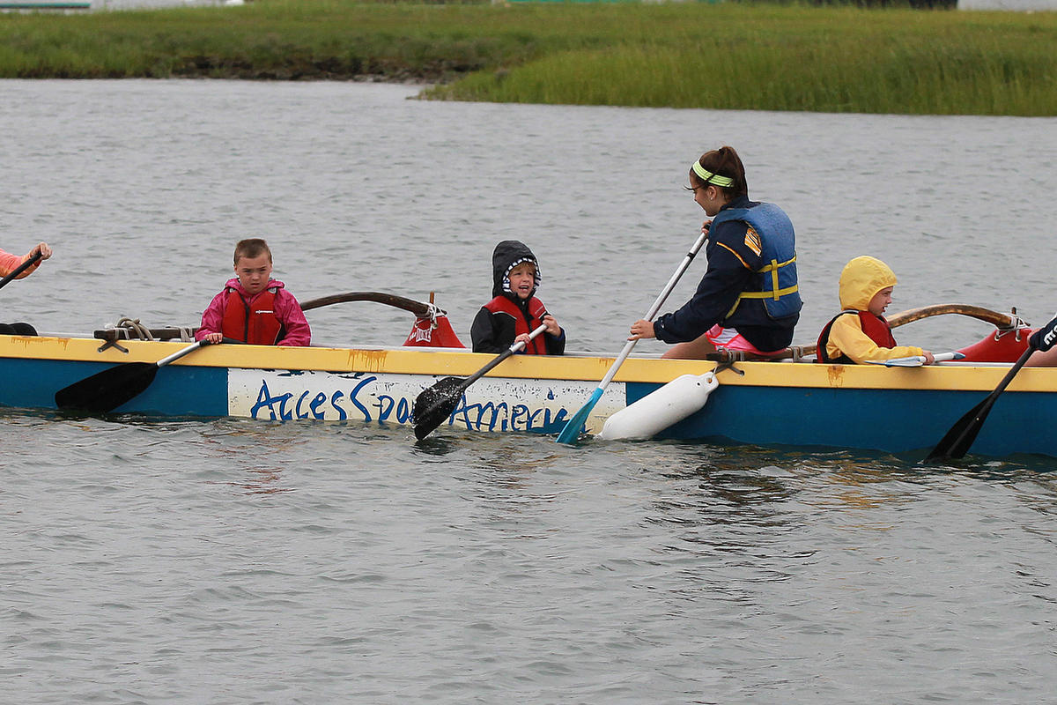
Kids row an outrigger canoe at a weeklong camp through Access Sport America.
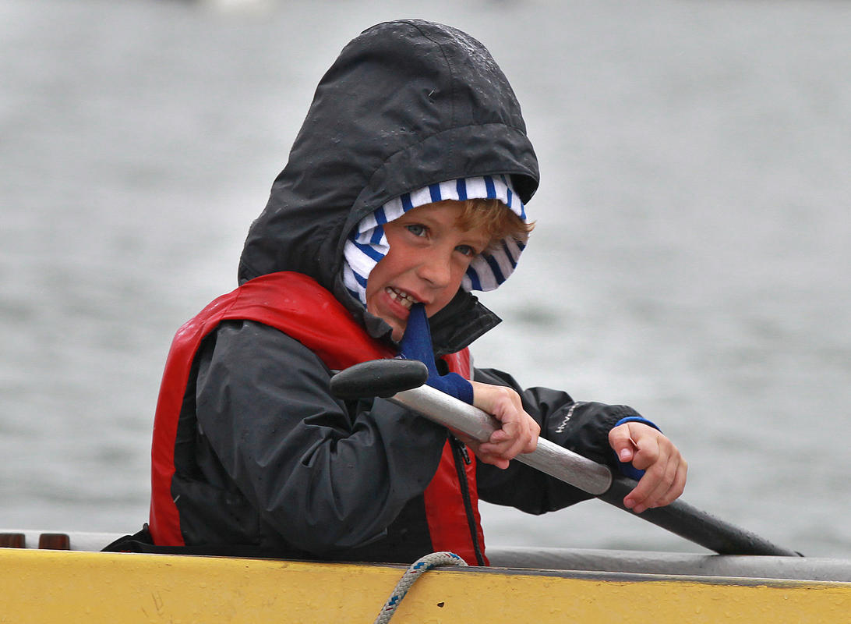

Drew McClellan paddles on an outrigger canoe at a weeklong camp through Access Sport America

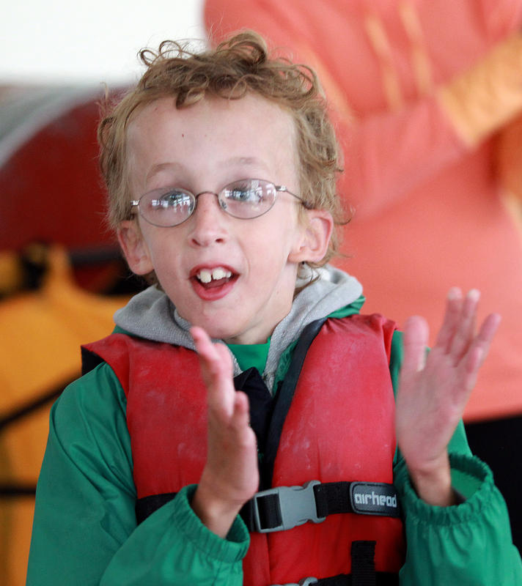
Zachary Gates claps during a bonding exercise as children learn to row, paddle board, and windsurf at a weeklong camp through Access Sport America.

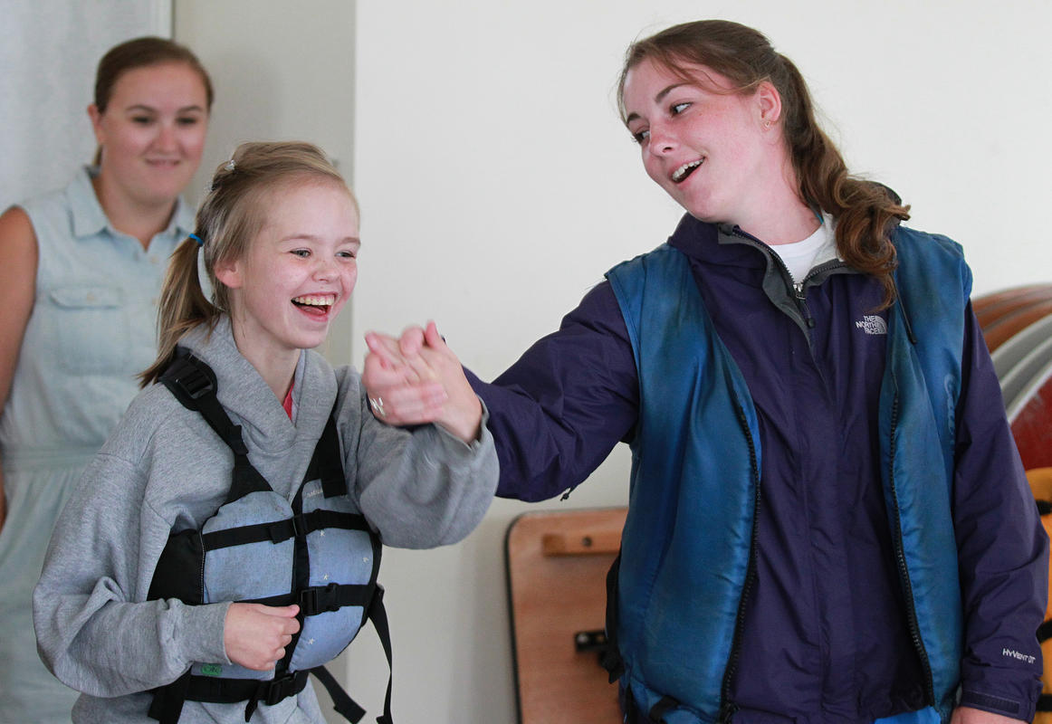

Karly Erickson and volunteer Kathleen Burke sing as children learn to row, paddle board, and windsurf at a weeklong camp through Access Sport America.

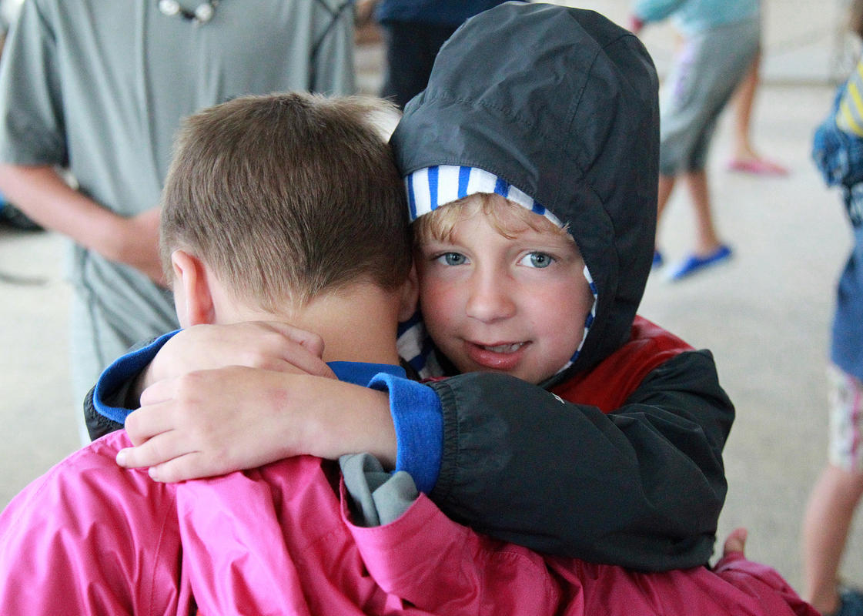

Stephen Fassnacht and Drew McClellan embrace before learning to row, paddle board, and windsurf at a weeklong camp through Access Sport America.

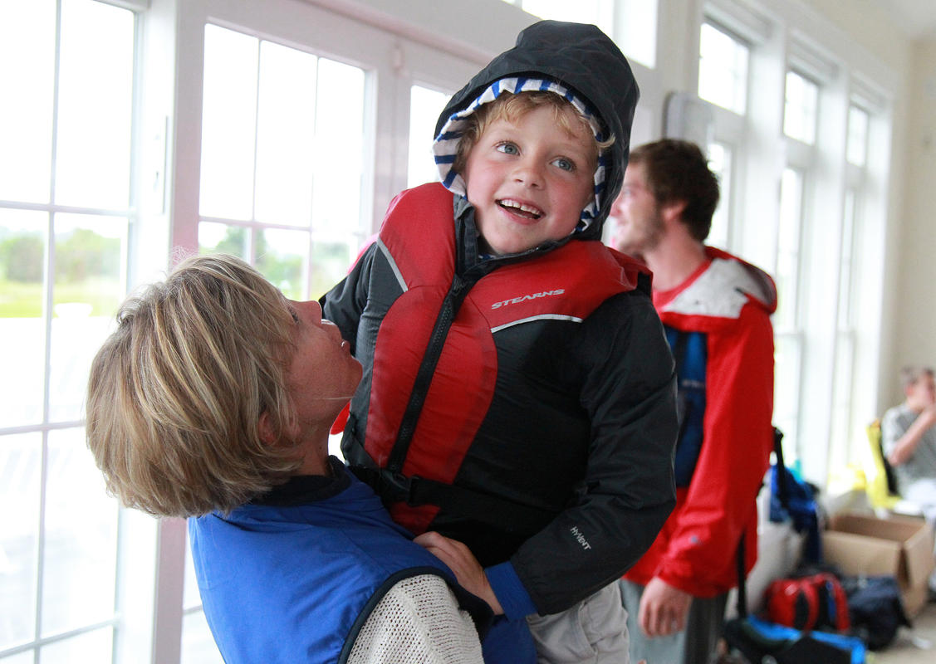

Gina McClellan hugs her son Drew 6, before a group of children learn to row, paddle board, and windsurf at a weeklong camp through Access Sport America.

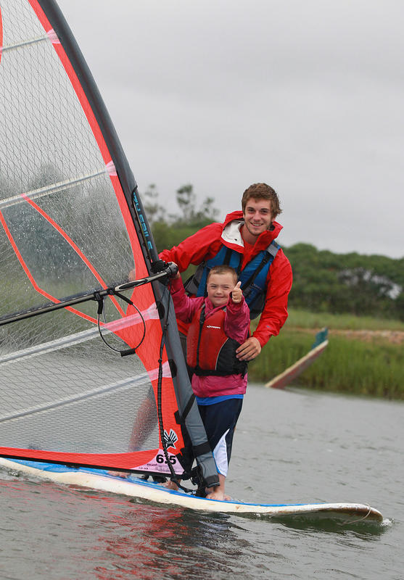

Stephen Fassnacht gives a thumbs up while windsurfing with Access Sport America staffer Connor Shea as children learn to row, paddle board, and windsurf at a weeklong camp.

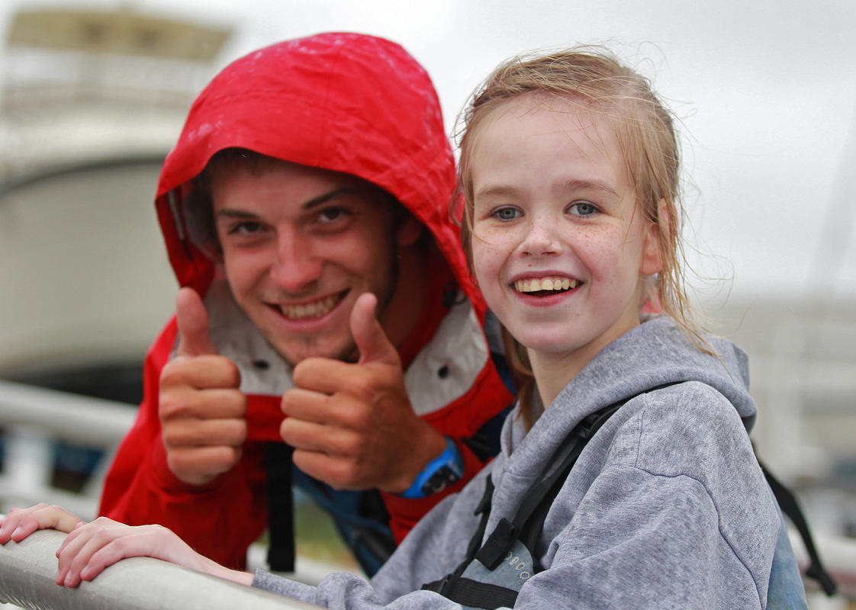

Access Sport America staffer Connor Shea shares a light moment with Karly Erickson after windsurfing at a weeklong camp.

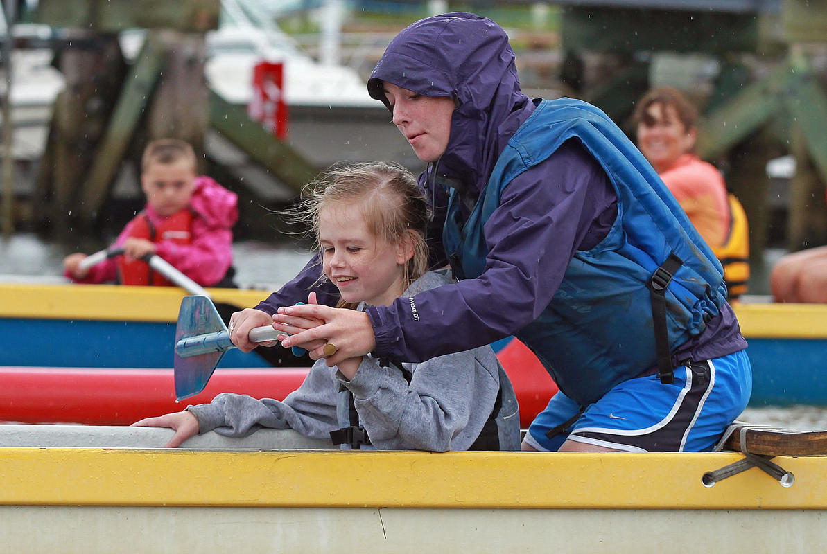

Kathleen Burke of the Scituate recreation department helps Karly Erickson paddle an outrigger canoe at a weeklong camp through Access Sport America.

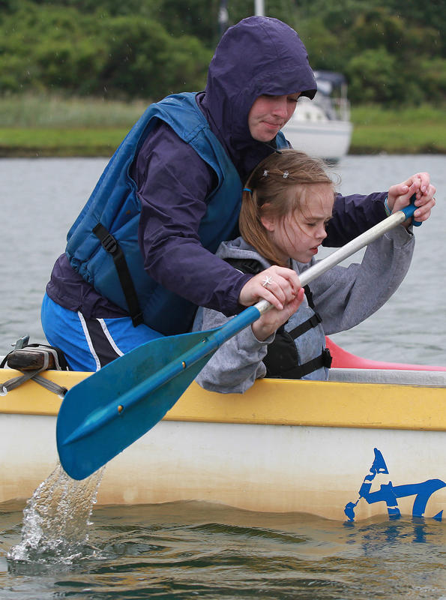

Kathleen Burke of the Scituate recreation department helps Karly Erickson paddle an outrigger canoe at a weeklong camp through Access Sport America.

