Scituate kids join Santa for holiday train ride

Posted Dec. 23, 2014 @ 3:25 pm

SCITUATE

The CORSE and SHORE organizations welcomed local kids to come aboard the North Pole Express with Santa and Mrs. Claus. They got to share what they wanted for Christmas, hear "The Polar Express," and enjoy milk and cookies on the holiday train ride.

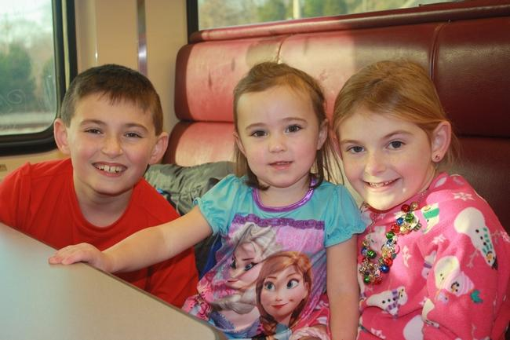
James McLean, Emory Loughlin, and Kathryn McLean wait with anticipation for their magical trip to start on the North Pole Express. Courtesy Photo

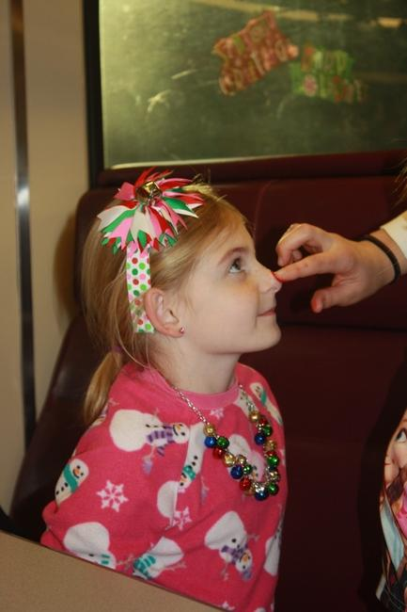
Kathryn McClean smiles as her red "Rudolf nose" is applied by a helpful elf. Courtesy Photo

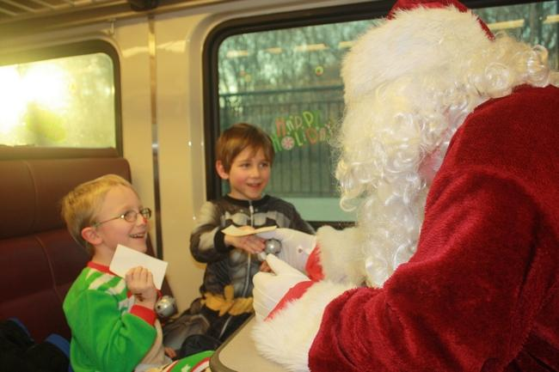

Santa chats with Charlie Putnam and Jacques Beal about what they want for Christmas. Courtesy Photo

