Scituate CORSE Foundation is community collaboration
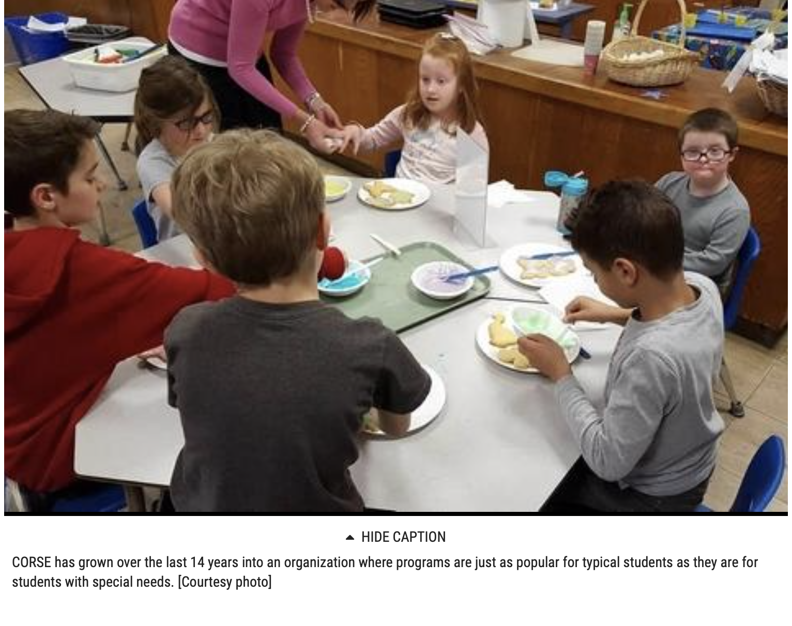

By Ruth Thompson rthompson@wickedlocal.com
Posted Jan 29, 2020 at 10:56 AM

The Scituate CORSE Foundation continues to bring members of the South Shore community together and to create special bonds and friendships through a variety of programs.

During the Jan. 27 Scituate School Committee meeting, Tracy Johnston – co-founder and president of CORSE, and Amy Pischel, vice president, presented the organization’s annual report and talked a bit about some of the accomplishments over the past year.

CORSE, which stands for Community Of Resources for Special Education, has grown over the last 14 years into an organization in which programs are just as popular for typical students as they are for students with special needs.

“We service students from pre-K thru 22 years old,” Johnston said. “Over the past couple years, we have created new work skills development initiatives to provide training and paid internships in collaboration with Scituate Public Schools, Scituate Recreation, and local businesses. We continue to provide social, academic, recreation and therapeutic programming as well as staff and parent training, and technology and equipment for the district.”

The organization now runs over 50 programs per year with more than 850 registrations and a programming budget of $150,000.

“Since 2006, we have invested over $1,275,000 with 626 programs and 9,148 student registrations,” Johnston said. “The organization is still managed by all volunteers at a 4.9 percent administrative overhead rate so every fundraising dollar truly goes to our children.”

While the organization still primarily serves students in Scituate, this last academic year CORSE had 1,117 registrations from kids across the South Shore including Weymouth, Hanover, Rockland, Whitman, Norwell, Hingham, Cohasset, Marshfield, Duxbury, Plymouth and Hull.

“CORSE is important to the South Shore community as it is one of the organizations on the South Shore that allow kids of all abilities to participate in structured and supported academic, social, recreation, therapeutic and work skills development programs,” Pischel said. “CORSE provides the individual support needed for every child regardless of ability to access and be successful in these programs. It is a true model of community collaboration.”

Programs
Some of the academic programs offered by CORSE include math and literacy homework and skill-building strategies for students in Grades 3 to 5. The first 15 minutes are spent working on math, literacy and executive functioning skills, and then helps participants with their homework.

Over the summer math, as well as reading and writing, are also offered to Grade 3 to 5 students.

Middle school and high school reading and math tutorials is available to students in Grades 6 to 12. This program provides a combination of instructional support and group work with ELA and math grade-level curriculum and summer packet assistance.

“Each program is run by SPS teachers and paras,” Johnston said. “These programs maintain a 4-1 ratio and if a child needs a 1-1 CORSE works with the SPS to provide that student a 1-1 aid.”

Social programs are offered during the academic year and summer cycles.

Circle of Friends and Sunshine Adventures help preschoolers of all abilities work on the social skills needed for kindergarten.

The immensely popular Best Buddies programs, for students from K to 12, enhance a caring and compassionate community that practices tolerance, peer assistance and acceptance of differences. Students attend monthly training programs and/or field trips and social activities after school throughout the academic year.

Instruction emphasizes the following areas: inclusion, exceptionalities and social thinking development skills.

“In all of our social programs the mentors benefit just as much as students with special needs,” Johnston said. “We also provide sibshops, music therapy and yoga and work skills development training and internships for the district.”

CORSE works hand in hand with Scituate Public Schools with the organization’s academic programs and Best Buddies, Johnston said.

“We work with Dianna Mullen, special education director, when any child needs a 1 to 1 to make sure that person has the correct person to work with them. We also work with her organizing speakers to come and talk to teachers and administration.”

CORSE provides social thinking curriculum for staff at each school in the district.

“We also bring in speakers for SPS staff on many topics ranging from social thinking to executive functioning to social/emotional development,” Johnston added. “Last year CORSE specifically provided SPS with $102,763 in programming that is 70 percent of our programming funding. The remaining funds went to Recreation programming and financial assistance.”

Recreation programming is another significant arm of CORSE with sports programs, summer camps, maritime adventures, skateboarding and therapeutic horseback riding.

Funding for CORSE programs comes from three major fundraisers – the CORSE Gala, the Polar Express, and the CORSE Golf Tournament and Par-TEE, Johnston said.

“We also receive funding from grants and direct donations.”

And what does the future hold for CORSE?

“We would like CORSE to continue to work with the Scituate community, businesses, and organizations to help grow our Internship programs as well as continue our collaborative relationship with both SPS and Scituate Recreation,” Pischel said. “We want CORSE to be seen as community resource not just a special needs resource.”

For information on the Scituate CORSE Foundation, visit corsefoundation.org.

