Kids enjoy fun and safe summer activities through Scituate CORSE Foundation
By Ruth Thompson
rthompson@wickedlocal.com
Posted Aug 12, 2020 at 8:00 AM

There may not have been a lot of opportunities this summer for children, especially those with special needs, to engage in memorable activities with their peers due to the COVID-19 pandemic, but the Scituate Community of Resources for Special Education (CORSE) Foundation, in collaboration with the Scituate Recreation Department, was able to offer programs that allowed kids to safely socialize and enjoy summer activities.
“For the safety and well-being of all of our children, parents, community volunteers and educators, CORSE programs followed the policy guidelines for summer programming decisions of Scituate Public Schools and Scituate Recreation who are our main partners in program collaboration,” said Tracy Johnston, co-founder of the Scituate CORSE Foundation and president of its Board of Directors.
CORSE has grown over the last 14 years into an organization in which programs are just as popular for typical students as they are for students with special needs.
“We service students from pre-K thru 22 years old,” Johnston said. “We continue to provide social, academic, recreation and therapeutic programming as well as staff and parent training, and technology and equipment for the district.”
Though CORSE was unable to offer its social and academic programs such as Best Buddies, math and reading tutoring that are typically provided each summer, they were able to run the very popular integrated All-Stars Ultimate Summer Adventures program.
They were also able to offer Therapeutic Horseback Riding again this summer through Briggs Stables in Hanover on a limited basis with parent support.
“The families and the kids are so grateful to have the opportunity to socialize with peers safely and create summer memories in these challenging times,” Johnston said.
CORSE held virtual programs for kids’ entertainment through a music sing-a-long with Scituate’s favorite music teacher, Peter Mundt, Johnston added.
The programs followed safety mandates and social distancing.
“Scituate Recreation has done an incredible job implementing the long list of state guidelines to insure safety by limiting group sizes, keeping groups separate, assuring social distancing within groups and mask wearing,” Johnston said. “We used this model as our baseline and added some additional safety measures. For example, we created visual social stories on mask wearing for children to understand their importance.”
For the All Stars program, the children were split into four separate groups - six children each, and with staff, each group was no more than 10. Each group spent the week together with a fun schedule of outdoor games, crafts, music and the Nona’s ice cream truck.
“One highlight was seeing how the kids each had their own individual space where they were hula-hooping, singing and dancing the whole time to music,” Johnston said. “Therapeutic Riding was a 1-1 ratio with masks and each child rode a total of six times over a three-four week period.”
Therapeutic Riding ended in early August and will be offered again next summer.
“The requirements for students were more strict than in the past with each student needing to be independent in their ability to sit up on the horse and steer their horse. Briggs worked with families to develop a flexible schedule which worked for their rider and the instructor. Riders enjoyed a variety of equine experiences from walking to games on horseback, to trotting. Riders enjoyed being outside, and having a physical activity.”
Knowing that children have not been able to easily see their peers and have not had much structured activity under adult facilitation, CORSE felt it was incredibly important that we do all we can to make whatever opportunities we could under our partners’ guidelines possible, Johnston said.
“Kids, especially those with special needs, need to stay connected. It was very inspirational to work with Scituate Recreation and Briggs Stable to be able to offer kids something positive in this challenging time.”
For more information on the Scituate CORSE Foundation visit corsefoundation.org

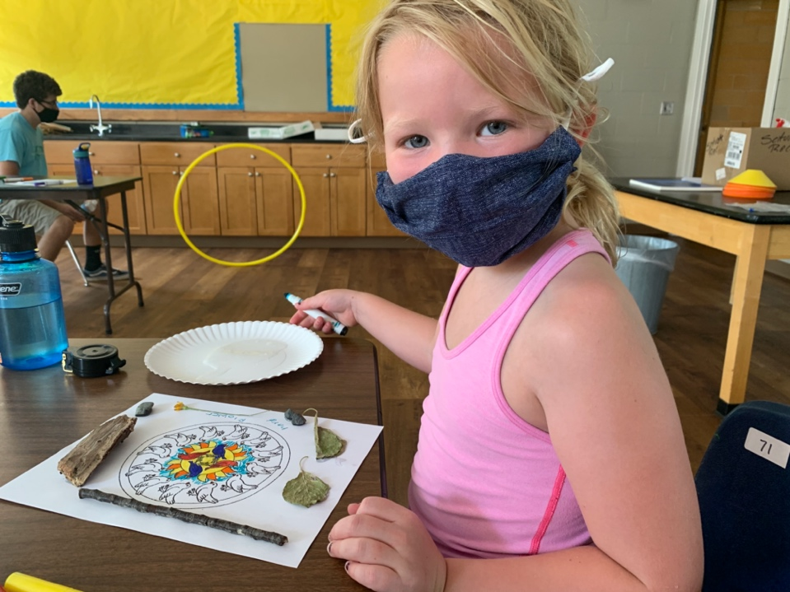

The Scituate CORSE Foundation, in collaboration with the Scituate Recreation Department,
was able to offer programs that allowed kids to safely socialize and enjoy summer activities.
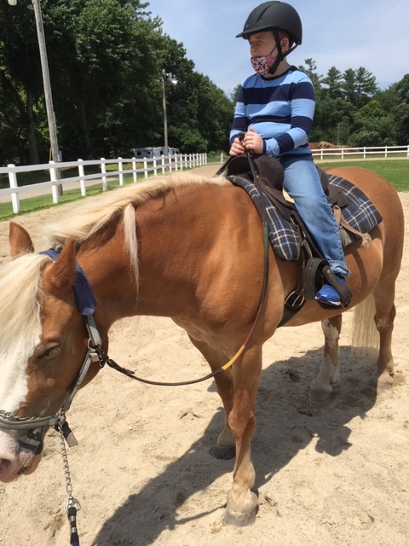
A popular program offered through CORSE is Therapeutic Riding, which took place
this summer at Briggs Stable in Hanover.

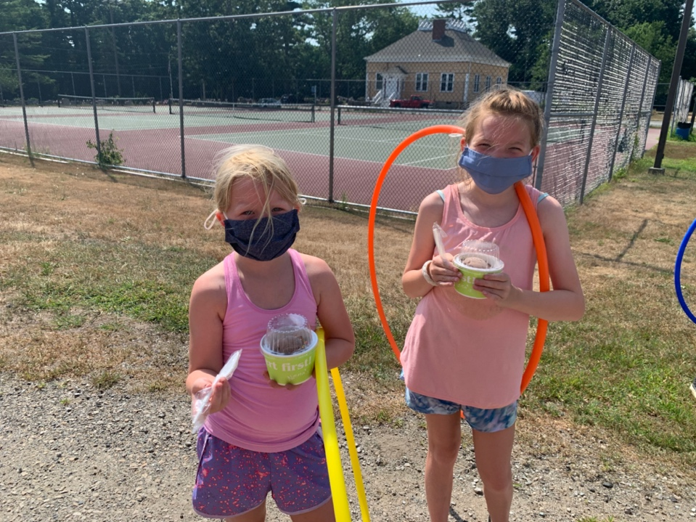

Children enjoyed safe, socially distanced and fun indoor activities as well as
outdoor activities through CORSE programs this summer.

