

CORSE set for fun
August 15, 2013

All AccesSports returned to Scituate Harbor this summer to give all kids a chance to get out on the water.

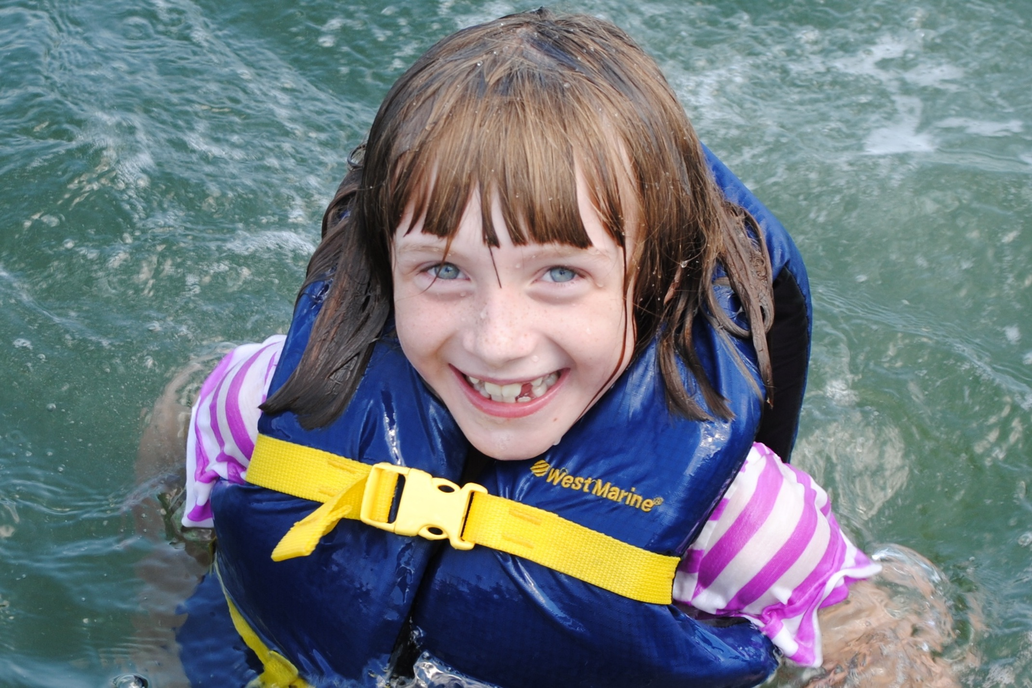

Kara McLaughlin cools off in the water.

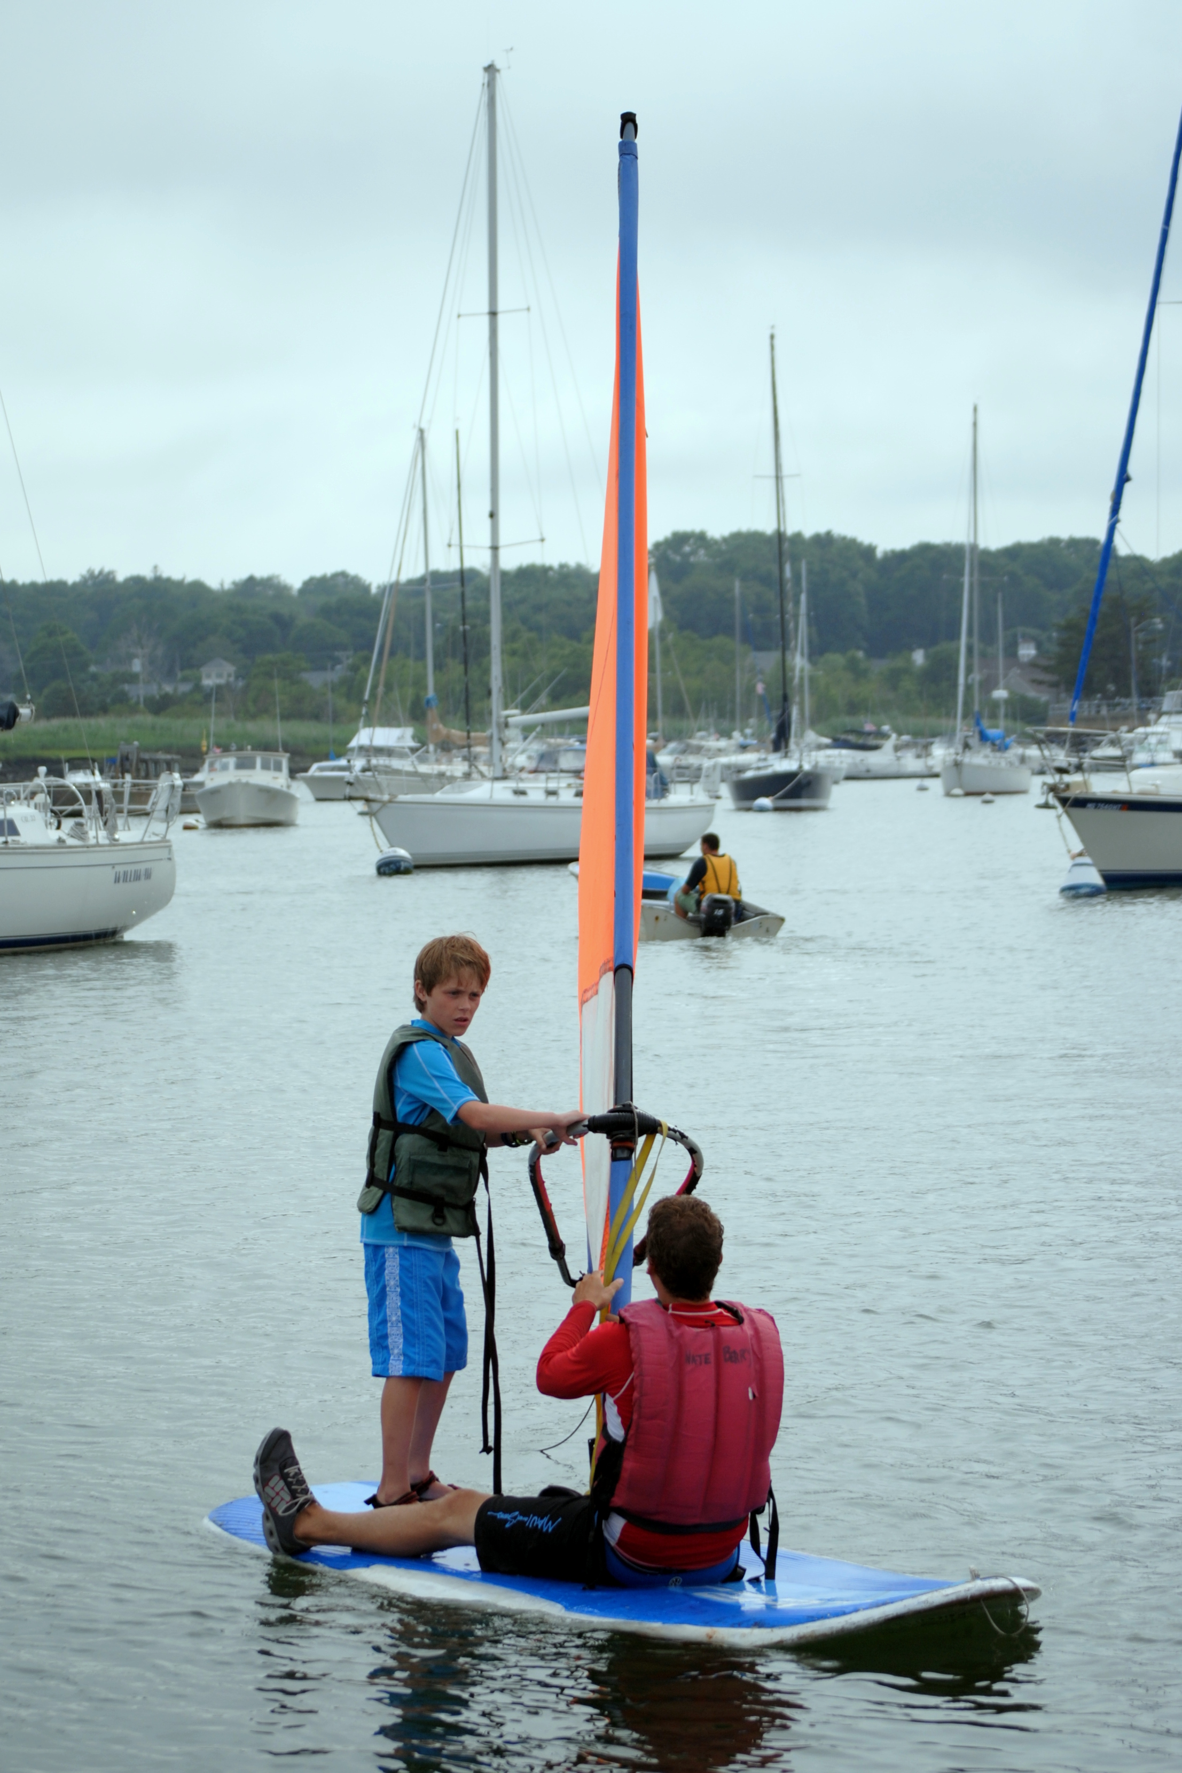
AccesSport Instructor Nate Berry with Gino Vitelli on a windsurfer.

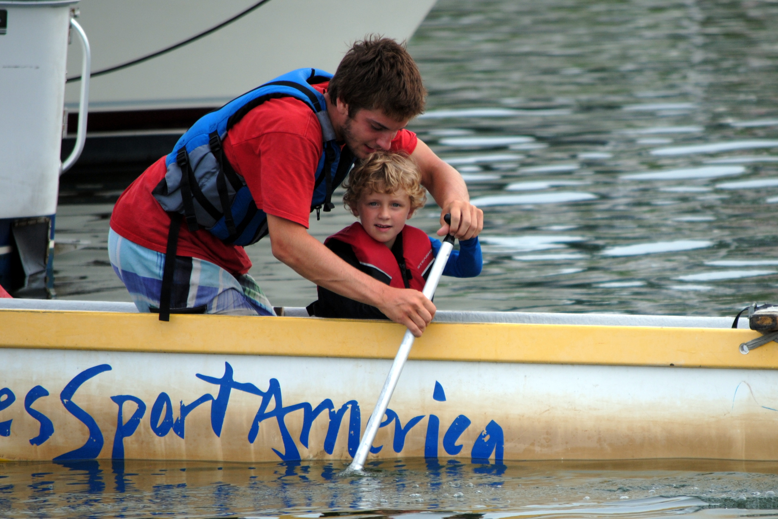

AccesSport Instructor Connor Shea with Drew McClellan out in the harbor.

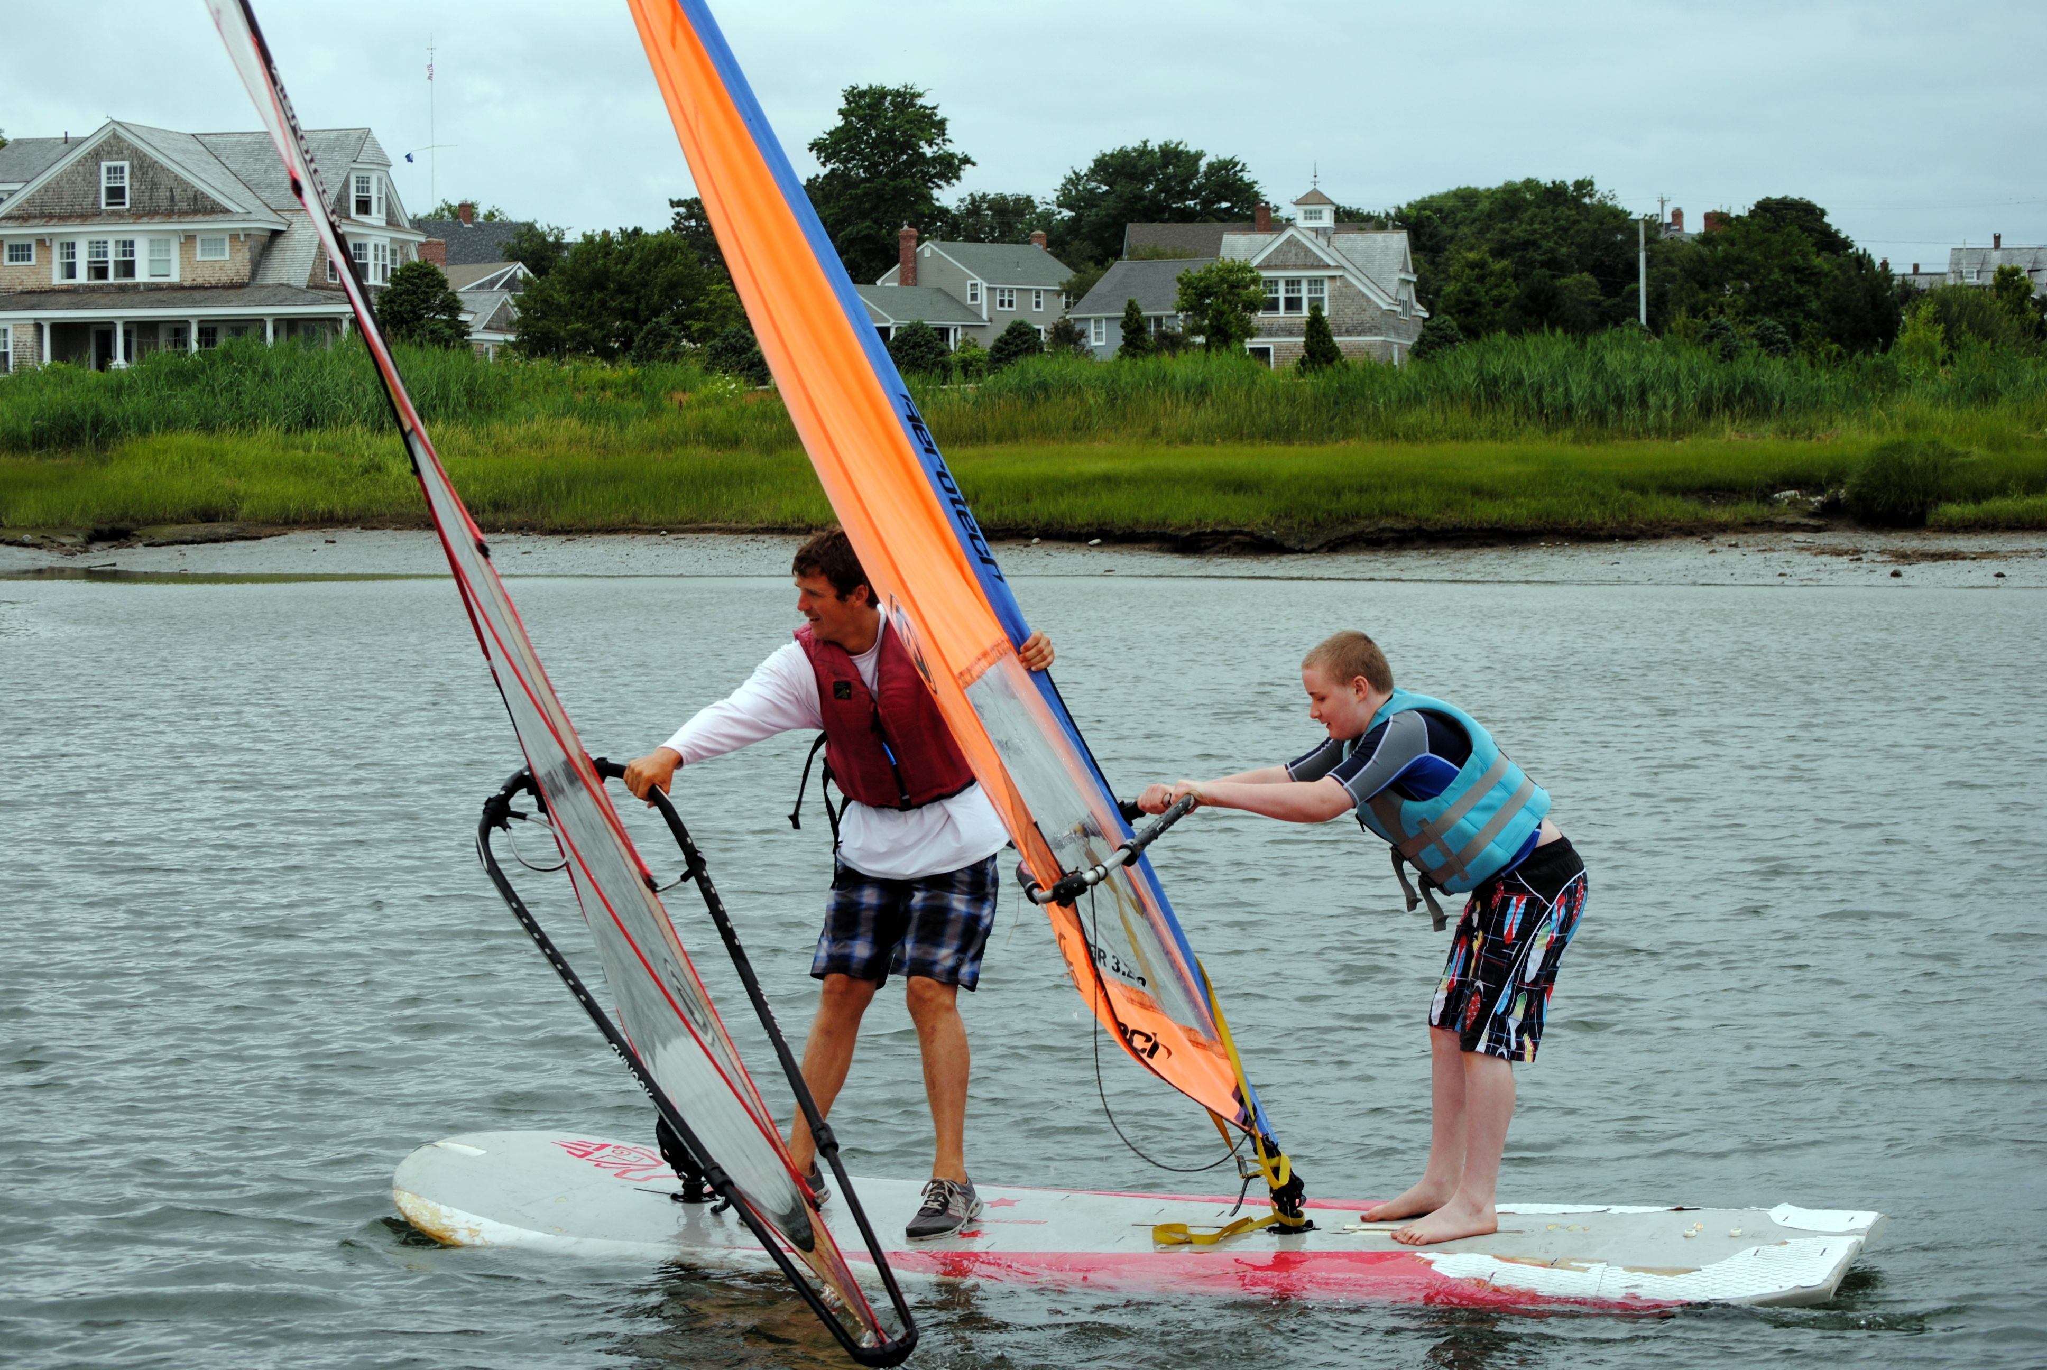

AccesSport Instructor Nate Berry with Owen Baum hang onto their sails.

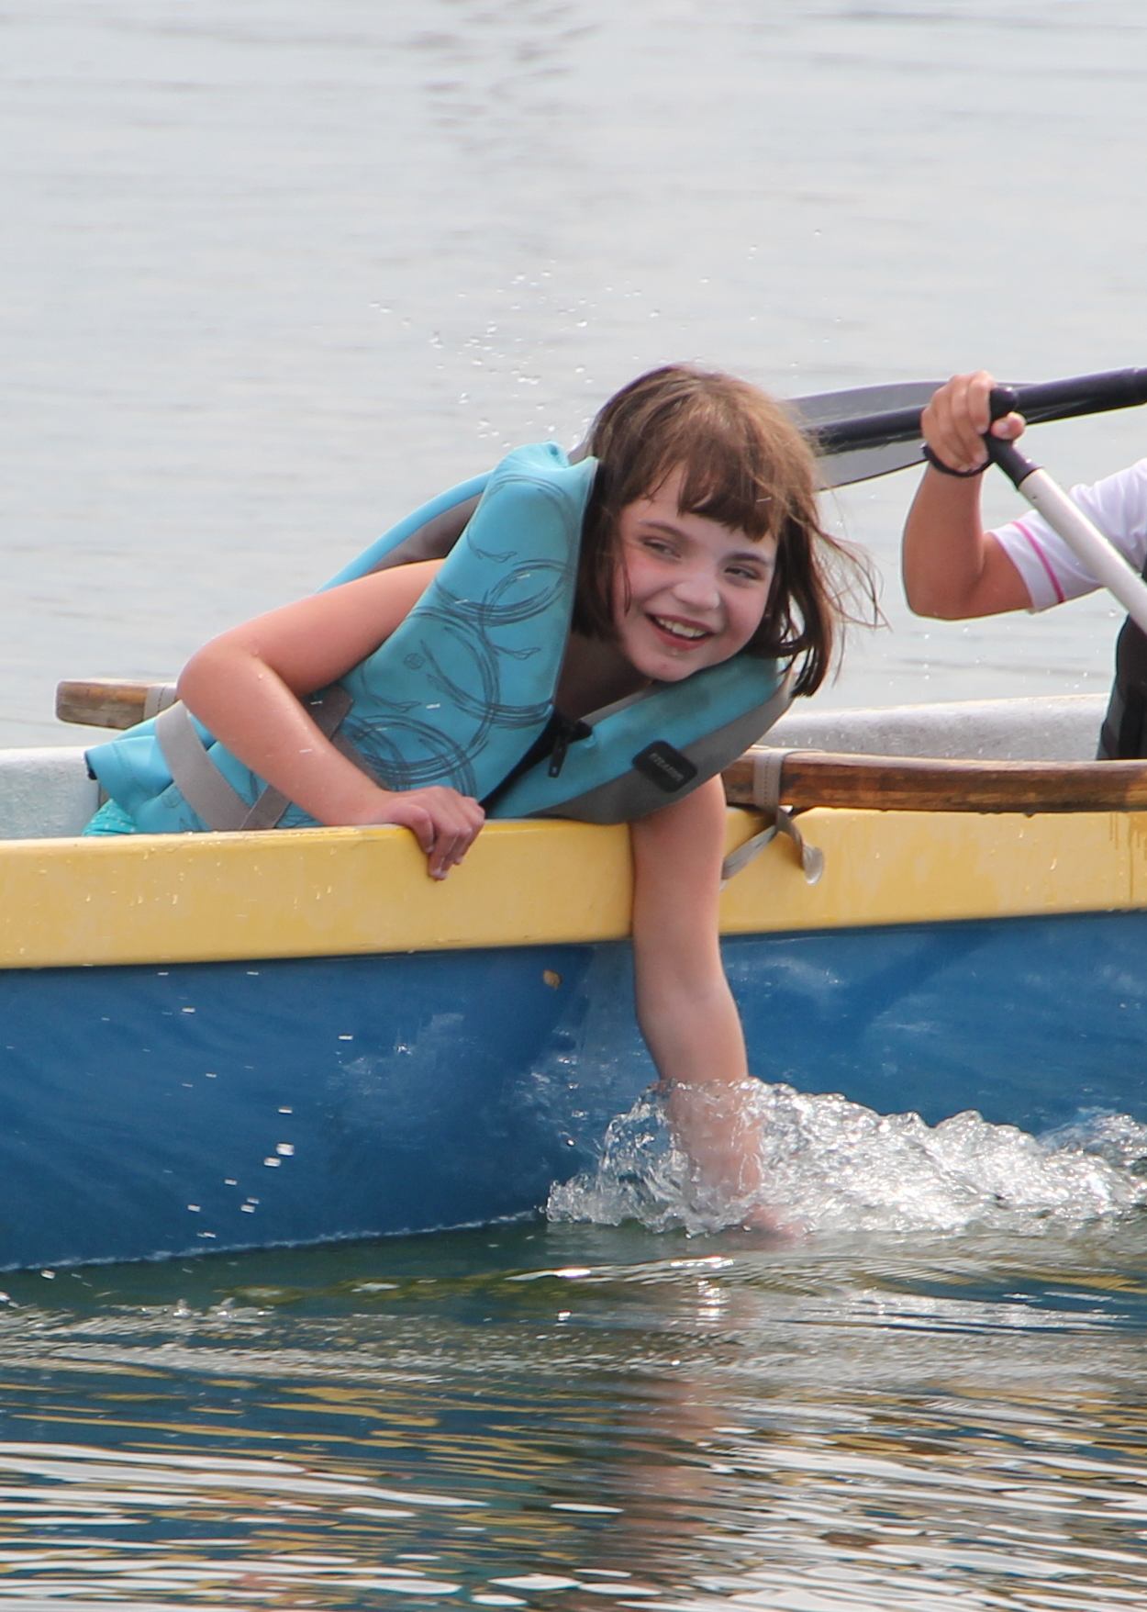

Maddie Legge feels the water as the boat floats across the harbor.

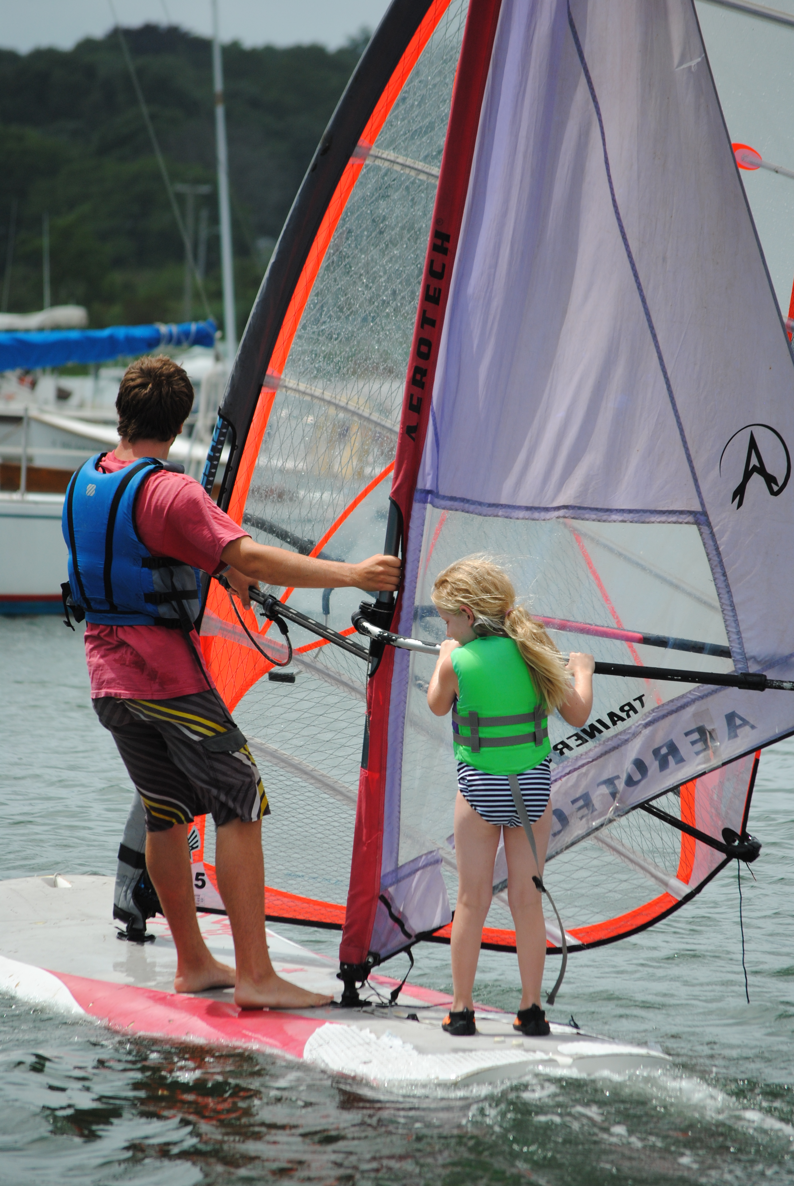

AccesSport Instructor Connor Shea and Fiona Faherty work together to get the windsurfer going.

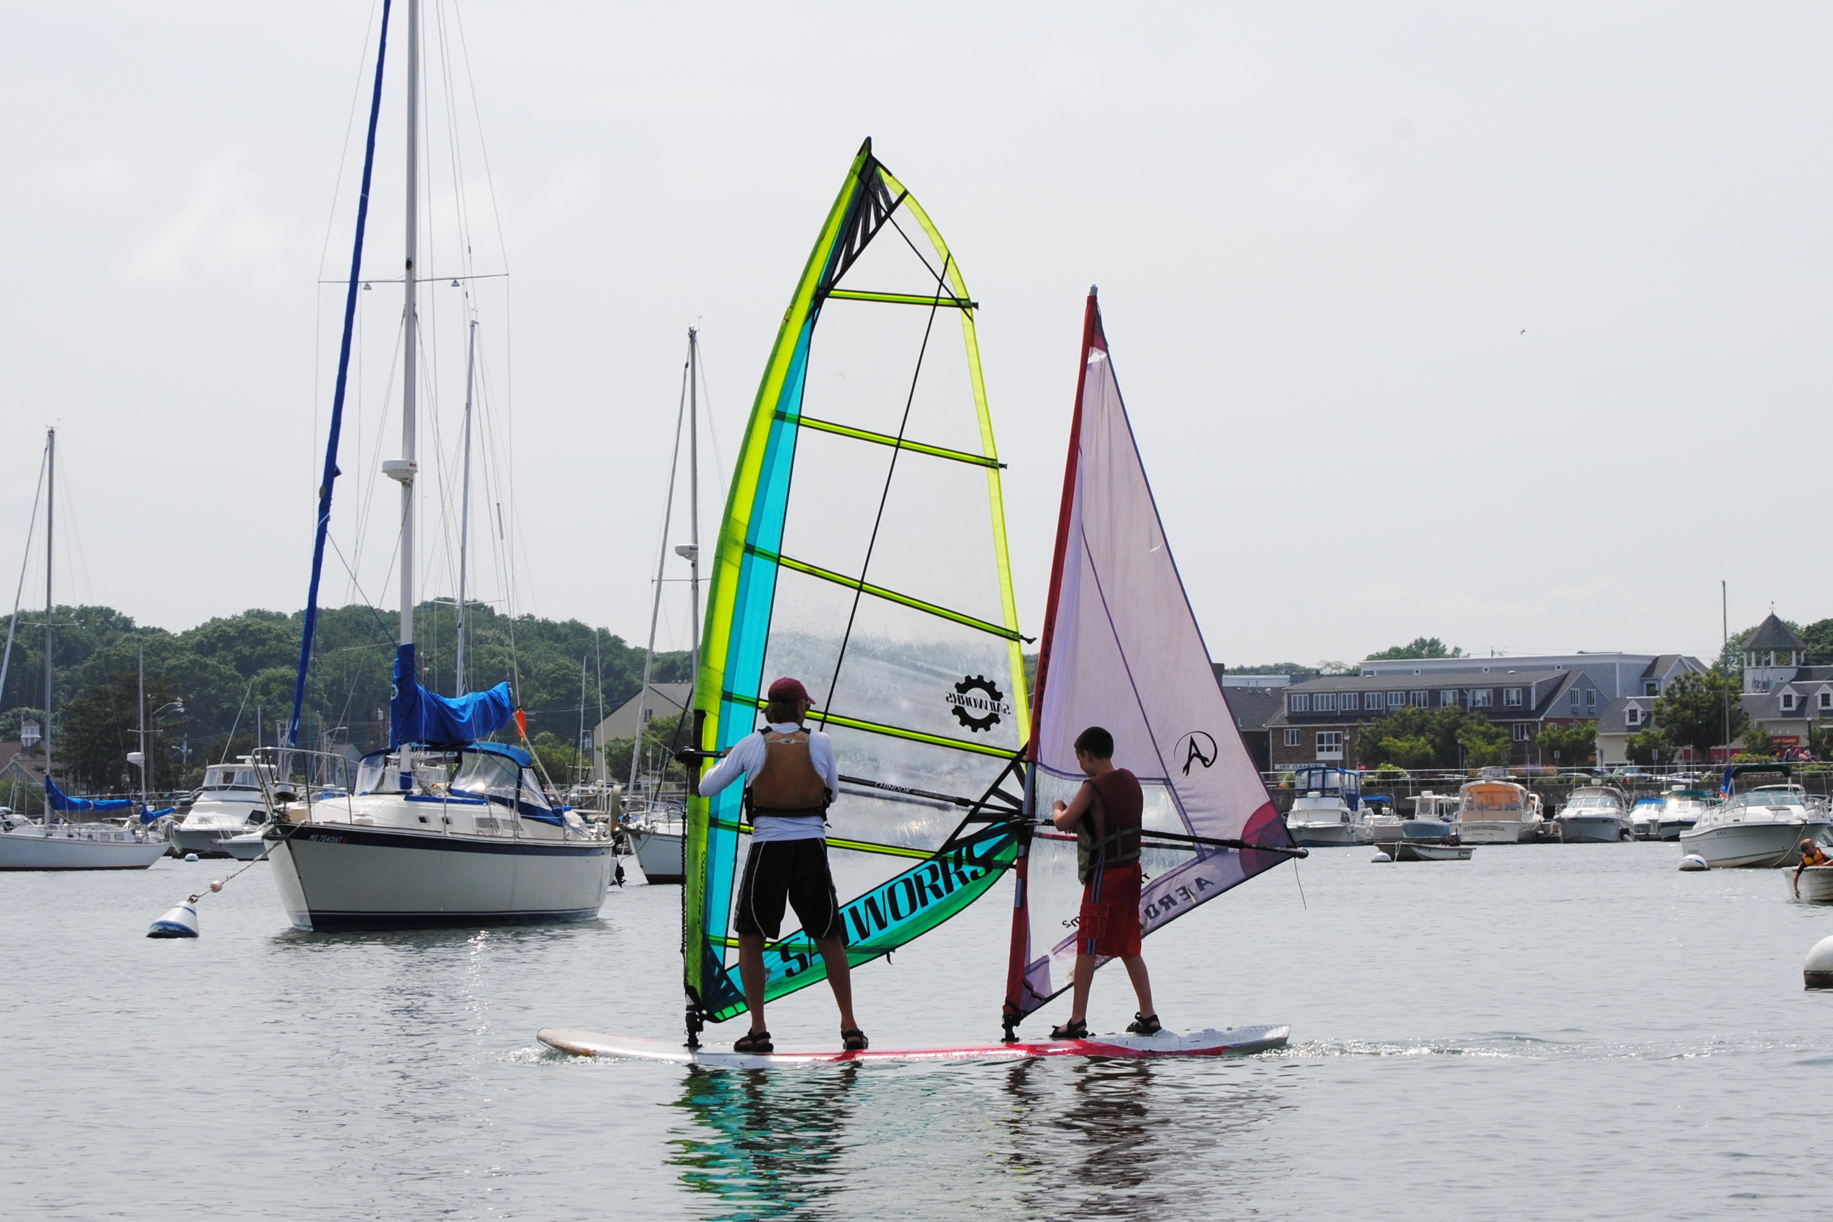

AccesSport Instructor Ross Lilley and Billy Johnston try out a little windsurfing.

