On the right CORSE

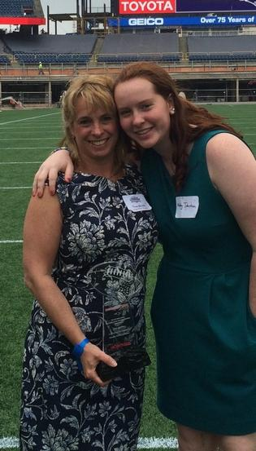
Tracy Johnston (center) was excited to meet Pats owner Tracy Johnston poses with daughter Abbey
Robert Kraft during the reception on the field. Courtesy photo at Gillette Stadium

Posted Jun. 17, 2015 at 5:00 AM
SCITUATE
Tracy Johnston, president of The CORSE Foundation (Community of Resources for Special Education), accepted a $10,000 award as one of 26 winners of the 2015 New England Patriots Myra Kraft Community MVP Awards.

She traveled to Gillette Stadium, met Patriots owner Robert Kraft, and learned she was a second-prize winner during a luncheon.
The New England Patriots Myra Kraft Community MVP Award recognizes deserving volunteers and inspires others to follow Myra Kraft’s example of being a life-long volunteer. Through this program, thousands of families in need throughout the region are supported by grants awarded to nonprofits in the name of outstanding volunteers.
The CORSE Foundation was established in 2006 to raise funds to provide the highest quality educational, social and recreational community experiences so children with special needs can reach their full potential. CORSE has raised more than $620,000 to fund professional development, equipment and technology, music therapy, parent resources and most significantly, social, academic and recreational student programming.

