Posted Jul. 28, 2014 @ 2:25 am
- Updated Jul 28, 2014 at 7:15 AM

- OUR OPINION: 3 stories of teaching lessons that matter
Editor's note: Readers often comment that there should be more good news in the paper. While it's true that there's more than enough bad news to go around, on Mondays on the Editorial page we will highlight some of the many good-news stories that appear on our pages on a regular basis.

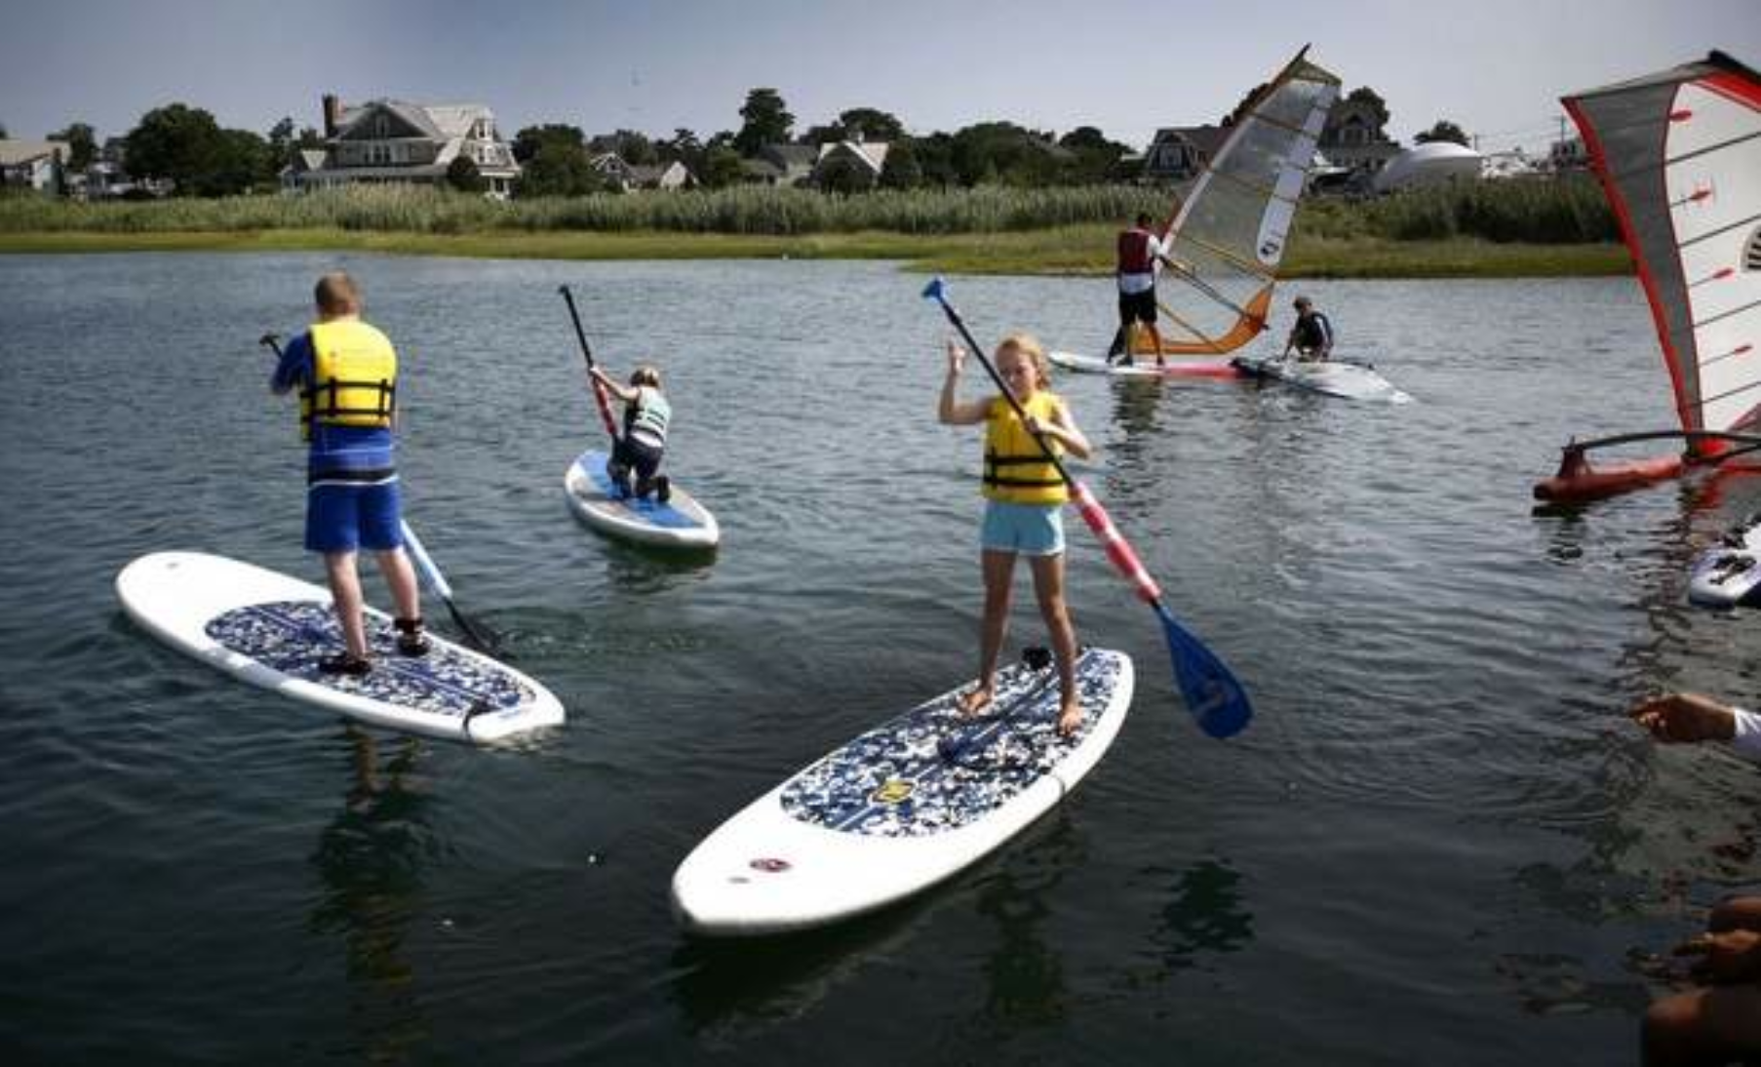 Nine-year-old Gretchen Voelger, center, navigates a board in Scituate Harbor in the Maritime Adventures camp on Wednesday, July 23, 2014.

No. 1: Maritime Adventures camp, Scituate
What is more fun for a child than grabbing a paddle and a board, and heading for the open water on a sunny day?
For typical kids, it’s a day at the beach. But while water sports may be an everyday pastime for many South Shore children, some with special needs may need special accommodations.
Knowing this, AccessSport America in Canton and Community of Resources for Special Education, a nonprofit, have teamed up to teach special-needs children that they don’t have to float through life but can swim. The town of Scituate lends its support by setting aside part of the harbor and providing sailboats and instructors. While there may be some initial anxiety, by the end of the lessons the kids’ confidence – and spirits – are high.
Abbey Johnston, 14, whose 12-year-old brother is on the autism spectrum, was so impressed she volunteered to help.
“The doctors say, ‘you’ll never be able to do this or that,’” said Abbey, “but (AccessSport) will find a way to get them out there. It’s amazing to see.”
We agree.

No. 2: New England Aquarium
Summer camp calls to mind swimming pools, canoeing and marshmallows by the fire. But for kids lucky enough to participate in the New England Aquarium Harbor Discovery Camp, they get to muck in marsh mud and find bugs – all in the name of science.
Funded by a grant from the Environmental Protection Agency, each week 32 kids explore, observe and test various marsh areas with aquarium guides, most recently in an area of the North River in Scituate. There the kids learned about crab traps, measured the marshes’ elevation and temperature and tracked wildlife.
Julie Simpson, a field scientist at MIT, verified the campers’ samples and said she hoped their work might be collected for use in a national database to track salt marsh research.
Perhaps the most important lessons the kids learned from the aquarium camp is that their local environment is multi-layered, containing worlds just beneath the surface, and that each and every one of them has something important to contribute to the greater world.

No. 3: Wakefield Estate, Milton
When we think of archaeological digs, we might think of dinosaurs in Montana or fossils in Arizona. But with the rich history we have in New England and specifically Massachusetts, there are certainly historic treasures to be found here. Thanks to the Wakefield Estate in Milton and the guidance of Boston University doctoral student Sarah Belkin, eight local high school students had a crash course in a professional dig this month. What they found is a layer by earthen layer record of the region’s politics, daily life and religion.
“You just kind of see what people were doing hundreds of years ago,” said Milton Academy sophomore Matt Magann.
That’s the goal of every sound educational experience: to teach the students how to see a world and life perspective beyond their own.
So far the dig has uncovered 80,000 artifacts, including a George Washington political pin, animal bones and ceramics.
We commend all involved in the hands-on lesson.

