CORSE celebrates the end of summer
Sep 06, 2013 @ 01:43 PM
CORSE recently celebrated the end of a summer of good times with a fun day held at Scituate High School. Lucky the Celtics mascot stopped by to meet the summer program participants and do a few of his famous aerial slam dunks.

Read more: http://www.wickedlocal.com/scituate/photos/x1655332582/CORSE-celebrates-the-end-of-summer?page=0#ixzz2eLFg0XV3
Follow us: @scituatemariner on Twitter | 221500301258840 on Facebook

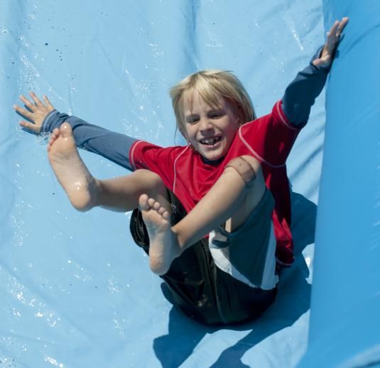

Dylan Rodgers, 7, flies down the inflatable slide.

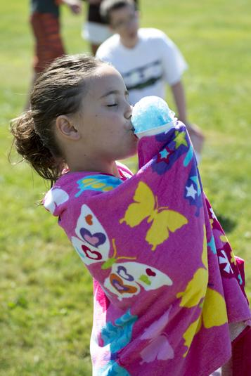
Skyla Burgess, 8, enjoys her sno-cone.

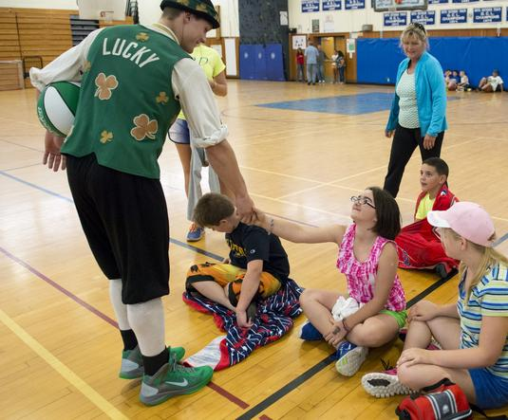
Sofia Teixeira, 12, meets Lucky the Celtics mascot during the CORSE Fun Day.

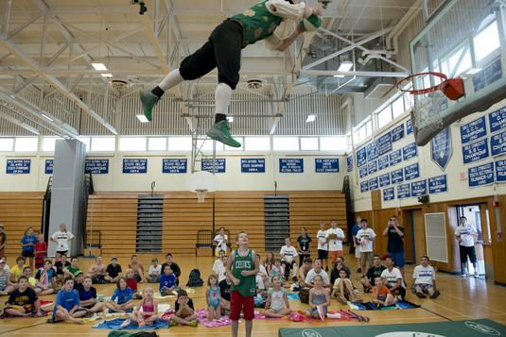
With an alley-oop from Billy Johnston (bottom, center), Lucky the Celtics mascot soars for a dunk.

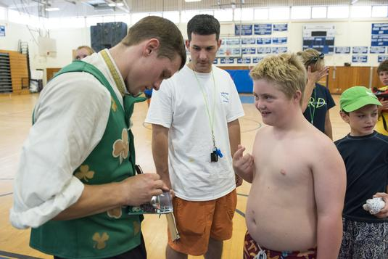
Cole Cadigan, 12, gets Lucky's autograph.

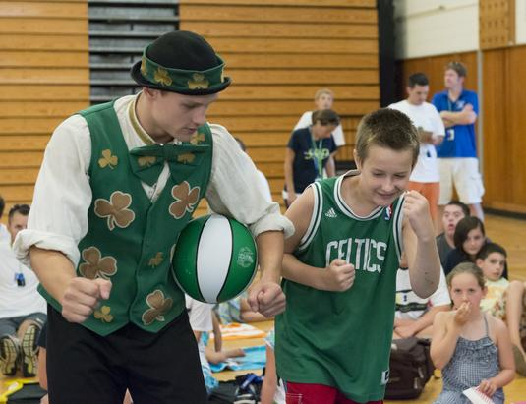
Lucky the Celtics mascot and Billy Johnston, 11, cha-cha during the CORSE Fun Day.

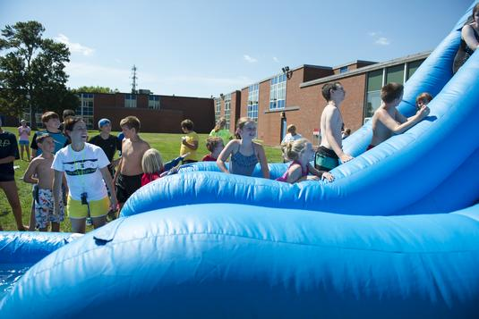
Counselors and campers have fun on the big water slide.

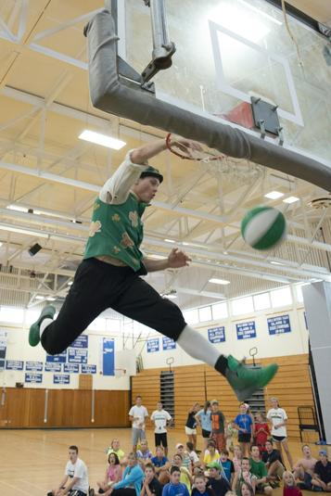

Lucky the Celtics mascot’s specialty is the slam dunk.

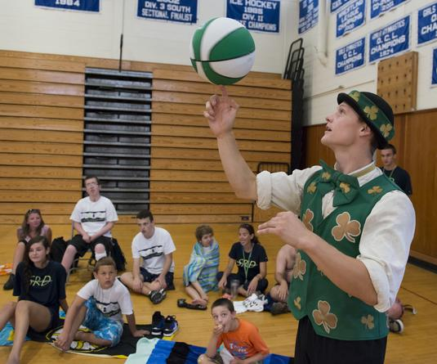

Lucky the Celtics mascot demonstrates his basketball skills for the crowd.

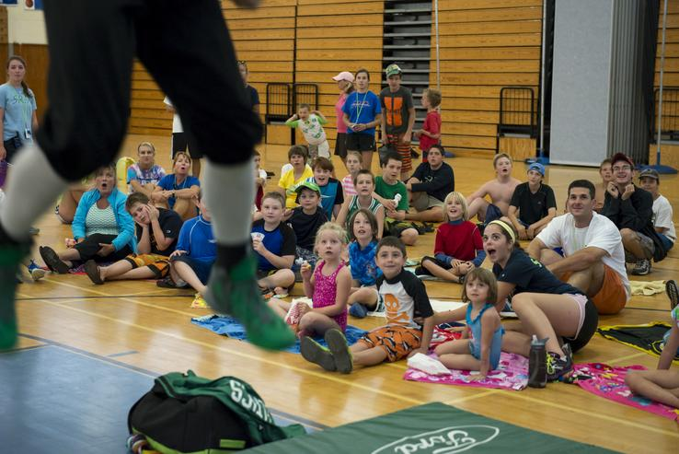
Lucky the Celtics mascot takes to the air for a dunk.

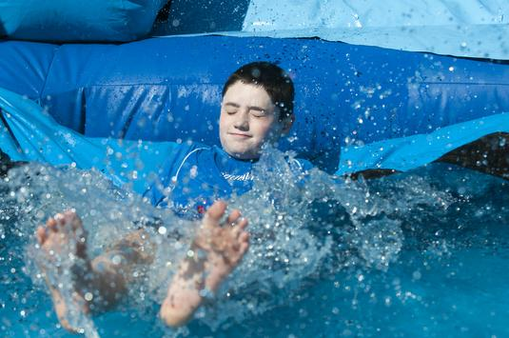
William Hoban, 10, makes a big splash.

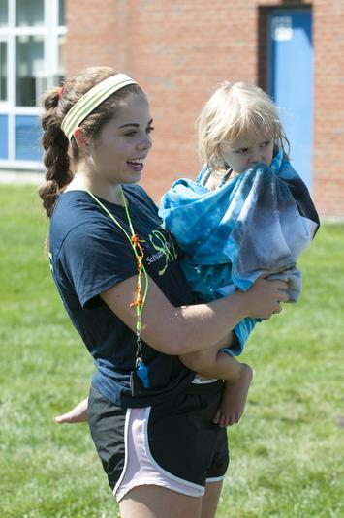

Cara McConaughey and MacKenna Luce, 3, have fun people watching during the CORSE Fun Day.

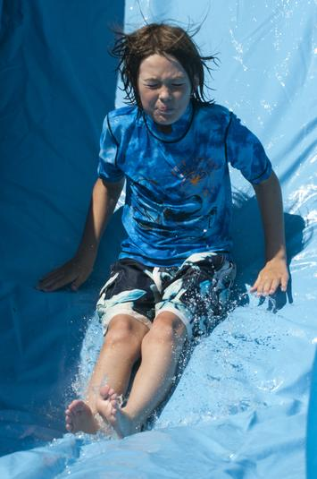
Josh Carey, 10, flies down the water slide.

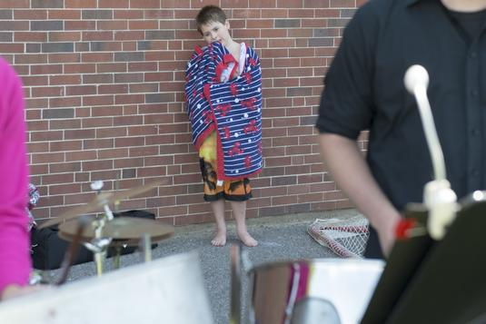

Matthew Davis, 8, takes a breather from the action to take in the sounds of the steel drums.

