By Jessica Trufant
The Patriot Ledger
Posted Jul. 24, 2014 @ 6:00 am
Updated Jul 28, 2014 at 11:21 AM
Scituate program gives kids of all abilities a chance at water sports

Dozens of children are spending time in Scituate this week building skills in windsurfing, Hawaiian outrigger canoeing, sailing and stand-up paddleboarding in the Maritime Adventures camp, which is offered through AccesSport America and the Community of Resources for Special Education, a nonprofit foundation.

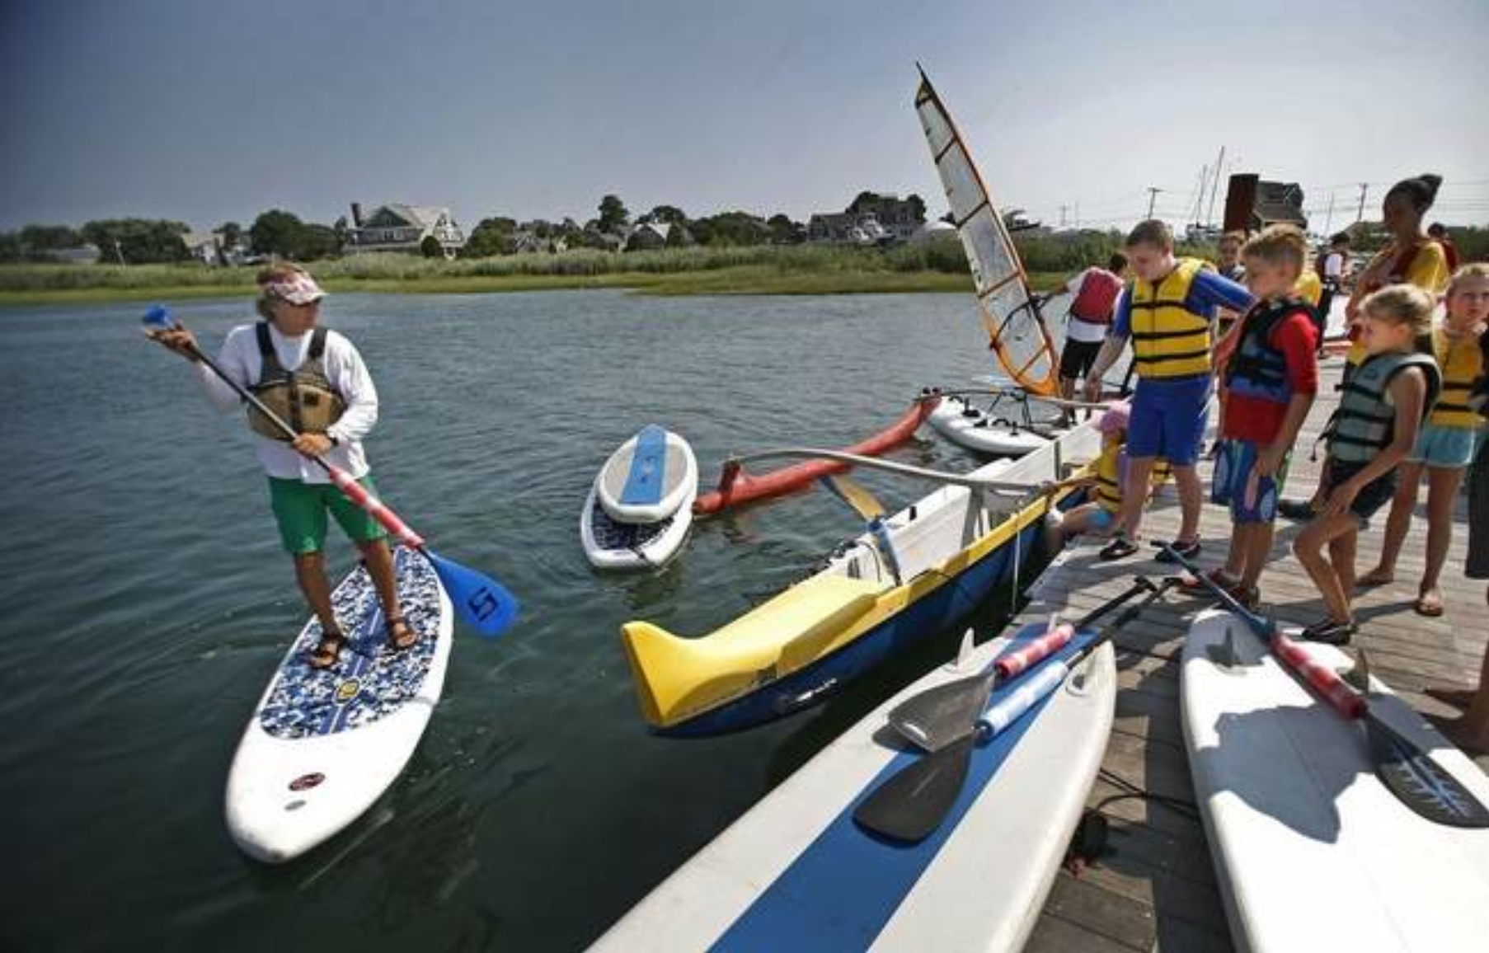

Ross Lilley, left, leads Maritime Adventures campers into the water on Tuesday in Scituate. Participants in the program; an offering of AccesSport America and the Community of Resources for Special Education (CORSE); get to try windsurfing, Hawaiian outrigger canoeing, sailing and stand-up paddleboarding. The photo was taken on Tuesday, July 22, 2014.
- SCITUATE – Without needing much assistance, 9-year-old Catherine Faherty fearlessly held onto the sail as the windsurfing board she was riding glided across the calm waters of Scituate Harbor.

- “I like windsurfing because it’s fun,” said Catherine, who stood alone on the board without needing her arm crutches. Catherine is among the dozens of children spending time this week building skills in windsurfing, Hawaiian outrigger canoeing, sailing and stand-up paddleboarding in the Maritime Adventures camp, which is offered through AccesSport America and the Community of Resources for Special Education (CORSE), a nonprofit foundation. The annual Maritime Adventures camp gives South Shore children with special needs a chance to experience the same summer activities that other children enjoy. AccesSport America, an Acton-based nonprofit organization, provides the personnel and equipment needed to offer challenging fitness programs for children with disabilities.

      - “It gives her the chance to do something she wouldn’t have the opportunity to do,” Catherine’s mother, Mary, said at the Maritime Center in Scituate Harbor. “It’s something that other kids do, and we like being on the water.” Kathleen Burke, a Scituate Recreation Department employee, said of Catherine: “She’ll do anything. She’s fearless.”

      - The participants are a mix of children from all over the South Shore. Some have learning and physical disabilities; others are typically developing children ages 6 to 18. Tracy Johnston, who co-founded CORSE in 2006, said special-needs children who take part in the program often go on to participate in regular recreation activities after they have gained some confidence. “At first there’s an anxiety, but by the end of the week they’re by themselves, and they leave here on Friday saying, ‘I want my own paddleboard,’” she said. “We feel very strongly that it’s important to be integrated with other children.” Since the children get to try a variety of activities, Johnston said the program is unique, even for typically developing children.

      - Johnston said the town has been a great supporter of the program, providing an area of the harbor and two Scituate Recreation Department sailboats and instructors. Abbey Johnston, a volunteer for the program, said the children get to experience more than they could have ever imagined. They include her 12-year-old brother Billy, who is on the autism spectrum. “The doctors say, ‘You’ll never be able to do this or that,’” Abbey, 14, said, “but (AccesSport) will find a way to get them out there. It’s amazing to see it.” The Scituate CORSE Foundation charges registration fees comparable to those for regular programming, even though the program costs more because of the need for specialized staffing. Fundraising and donations make that possible.

For more information, visit www.corsefoundation.org.

Kids learn to sail in Scituate
Students in a Community of Resources for Special Needs of Scituate maritime program got on the water with paddle boards, wind surfers and canoes Wednesday.
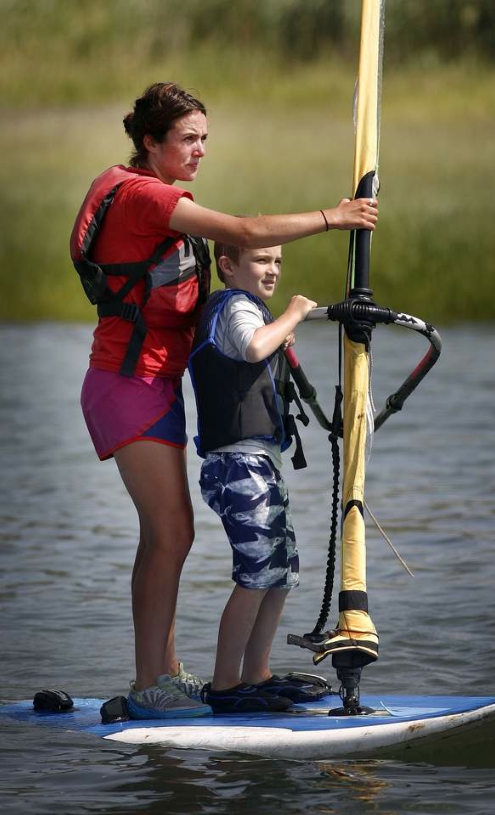
Instructor Caitlyn Donovan of Braintree works with student Liam Holden, 7, of Scituate on a wind surfer, Wednesday, July 23, 2014.
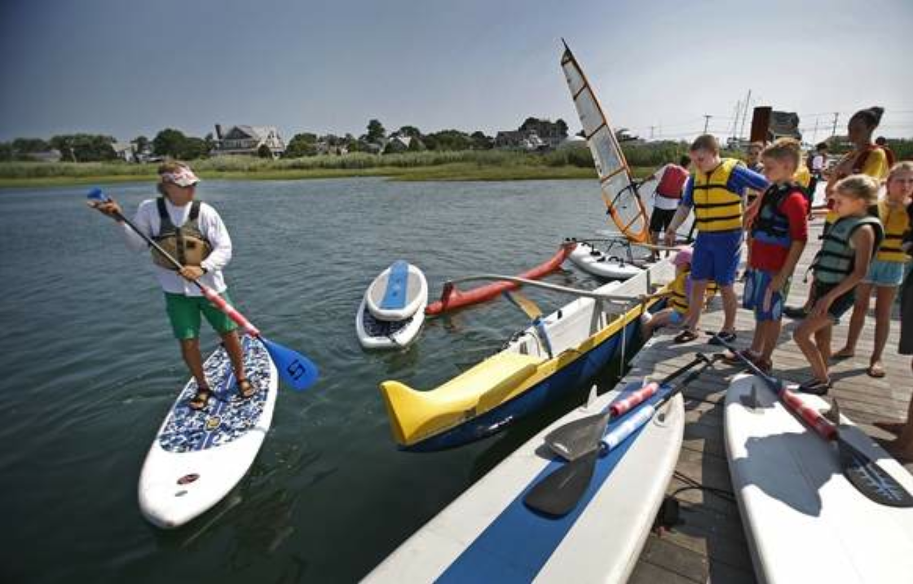
Ross Lilley, at left, leads kids into the water, Wednesday, July 23, 2014.

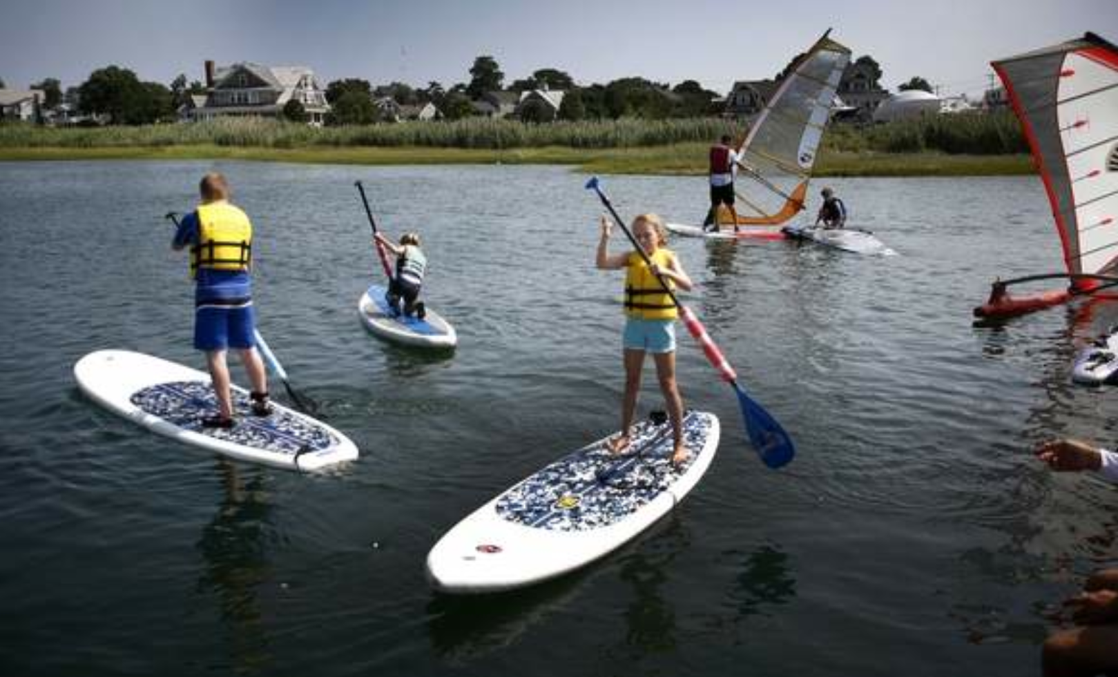
At center, Gretchen Voelger, 9, navigates a board in the harbor, Wednesday, July 23, 2014.

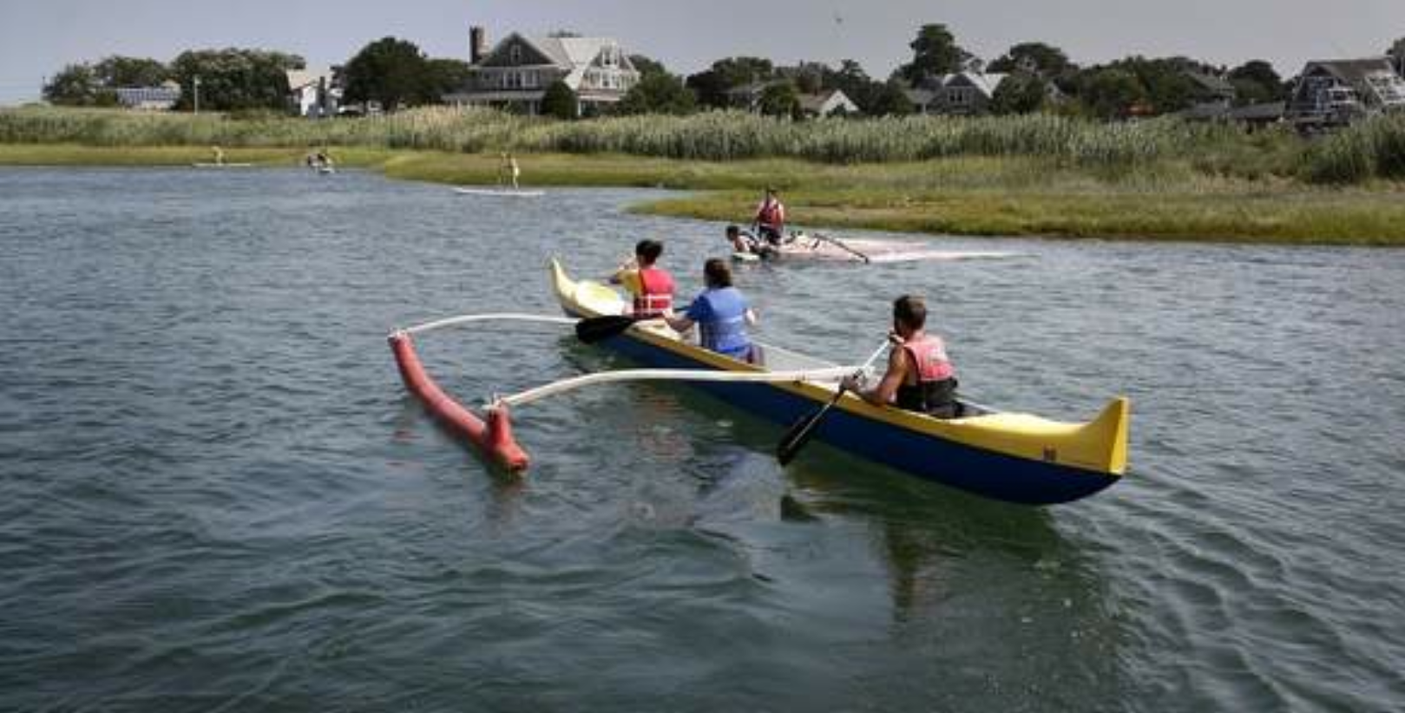
Kids and instructors use an outrigger canoe on the harbor, Wednesday, July 23, 2014.

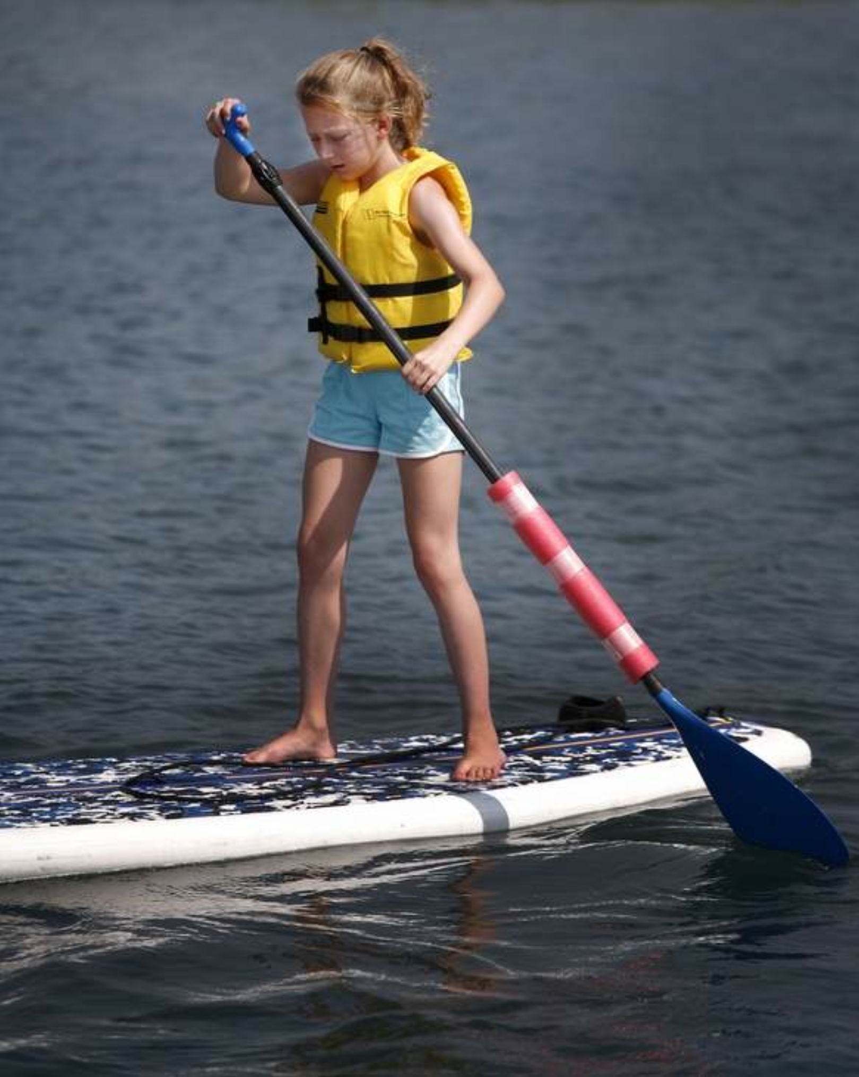
Gretchen Voelger, 9, of Scituate, Wednesday, July 23, 2014.

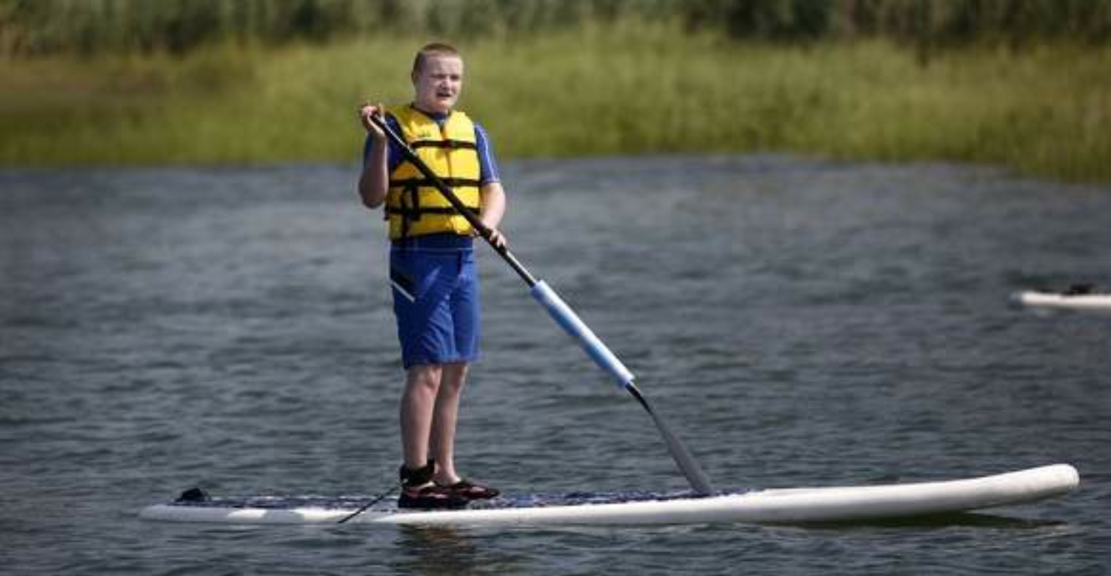
Owen Baum, 13, of Norwell, Wednesday, July 23, 2014.

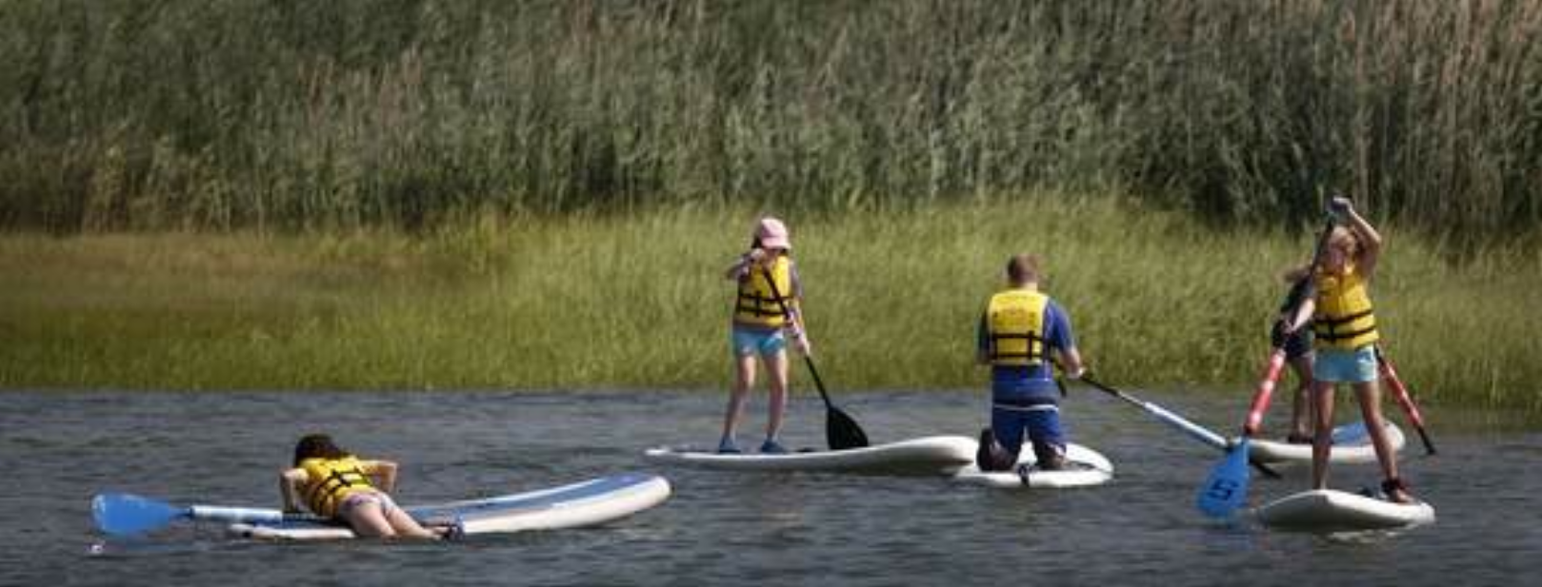 Students in a Community of Resources for Special Needs of Scituate maritime program get on the water with paddle boards, wind surfers and canoes, Wednesday, July 23, 2014.

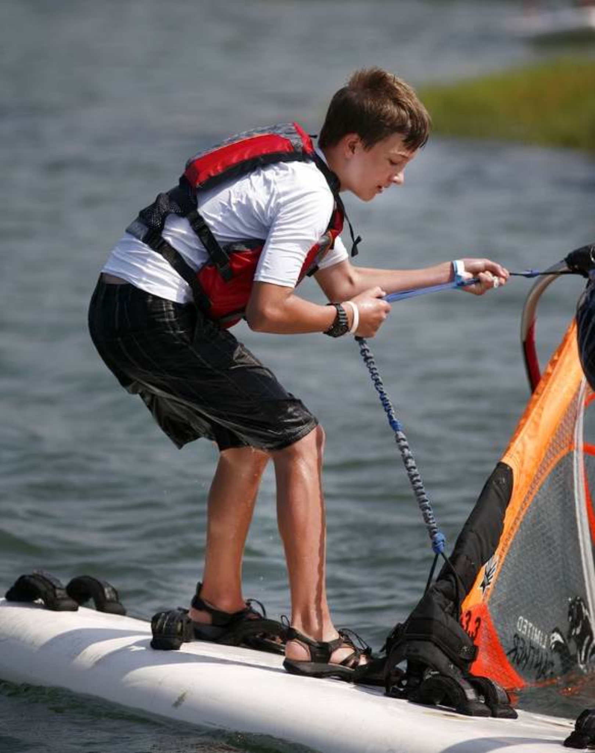
Declan O'Neill, 13, of Scituate pulls up the sail on the windsurfer, Wednesday, July 23, 2014.

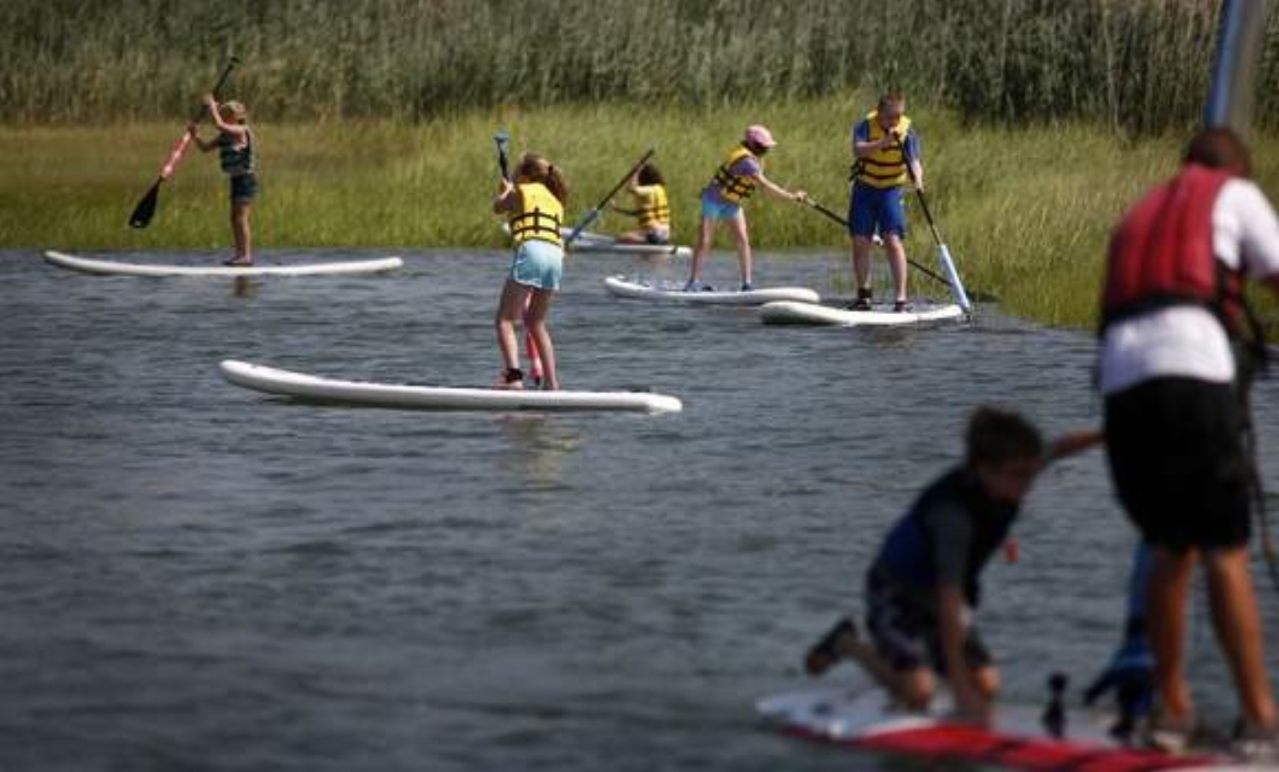 Students in a Community of Resources for Special Needs of Scituate maritime program get on the water with paddle boards, wind surfers and canoes, Wednesday, July 23, 2014.

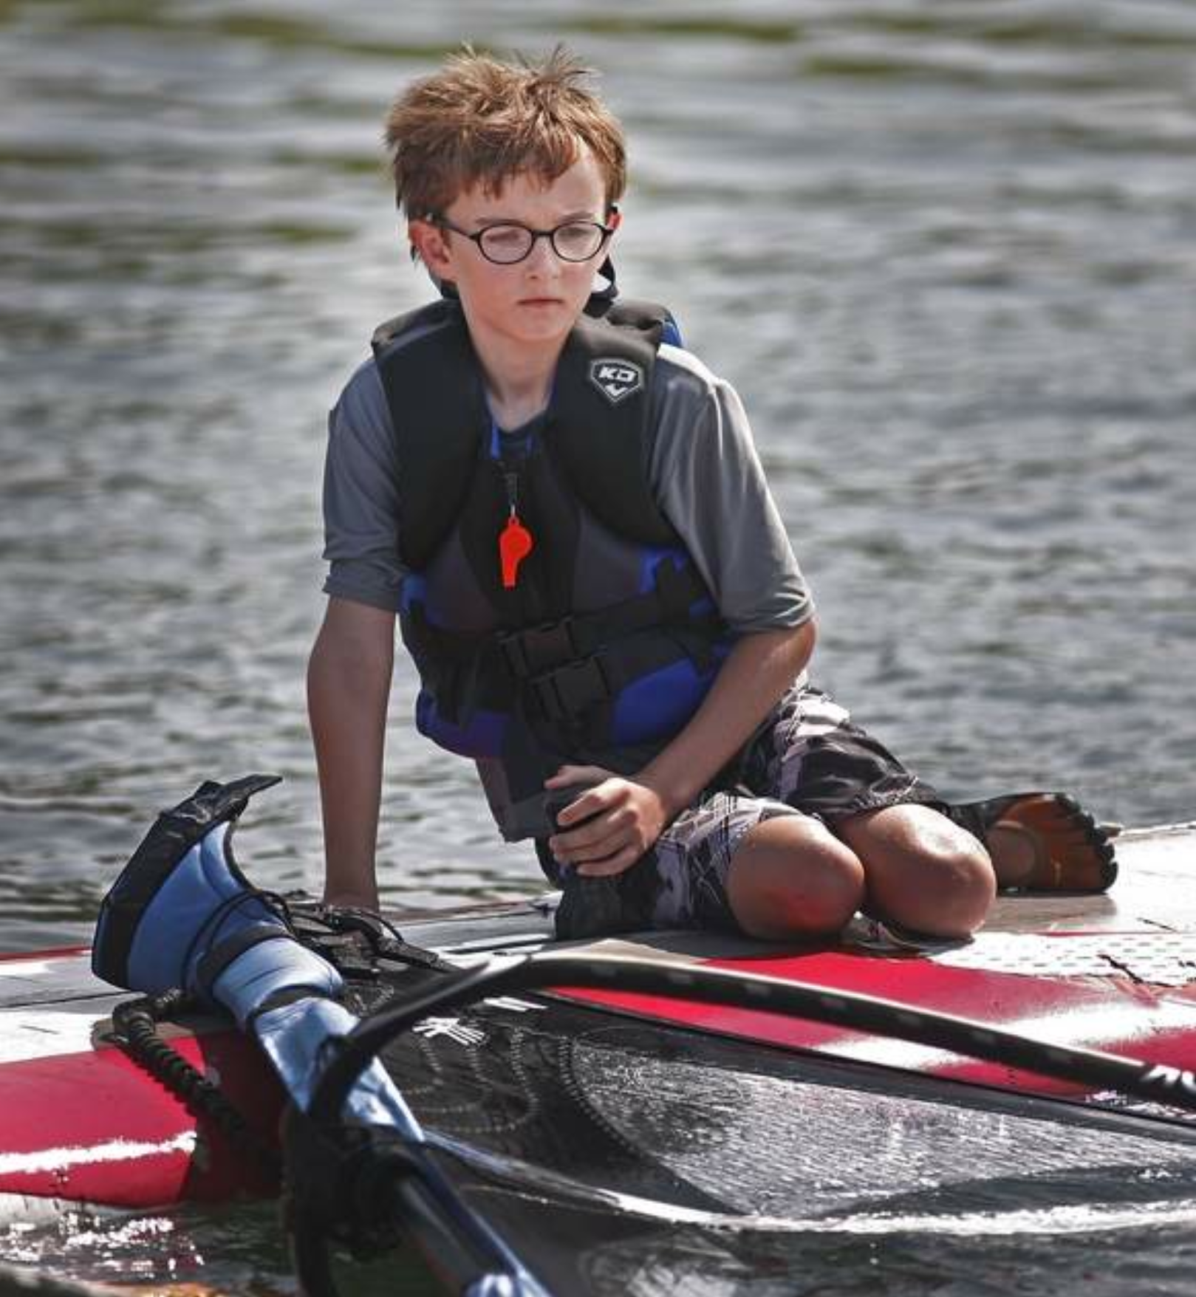
Aidan O'Neill, 11, of Scituate, Wednesday, July 23, 2014.

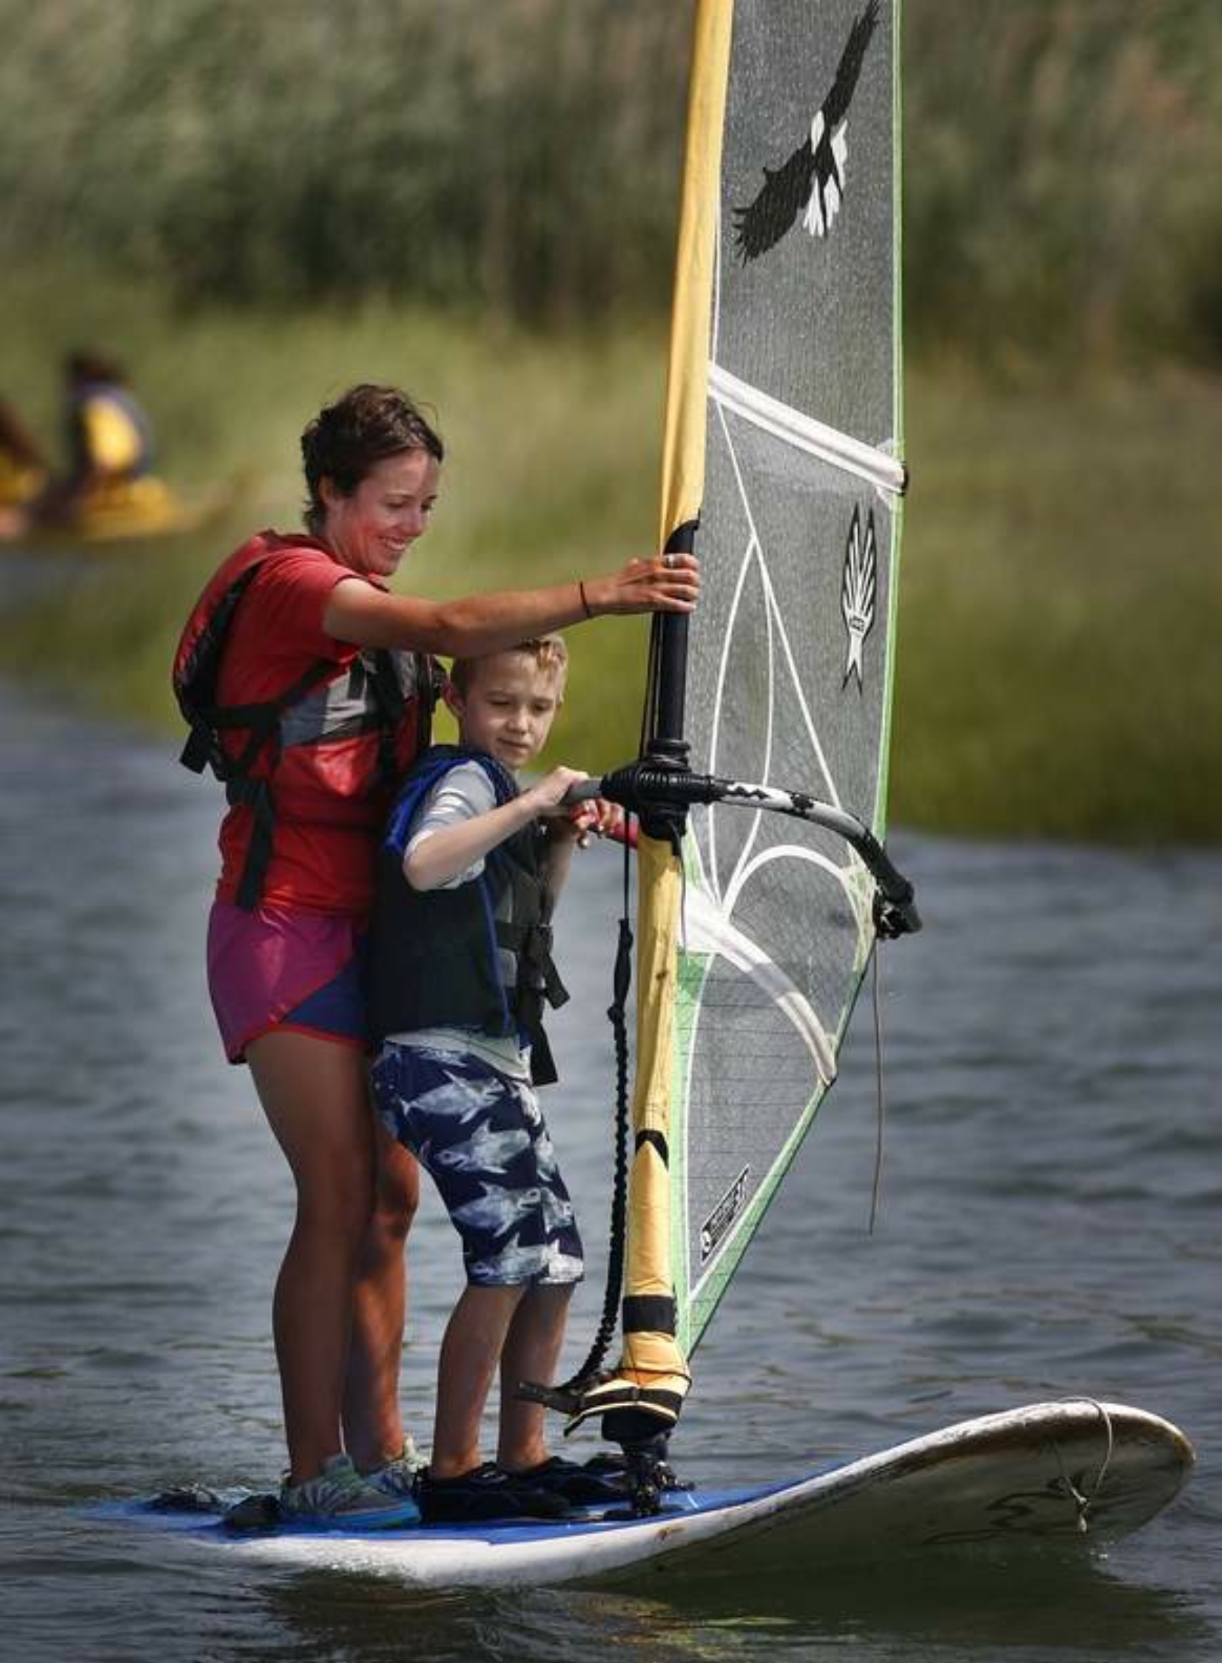
Instructor Caitlyn Donovan of Braintree works with student Liam Holden, 7, of Scituate on a wind surfer, Wednesday, July 23, 2014.

