For passion and dedication

WBZ names the CORSE Foundation feature charity of the month

The CORSE Foundation (Community of Resources for Special Education) was established by a group of dedicated parents and educators to raise funds to provide high quality and affordable programming, training and resources that will benefit children with special needs ages 3-22, their families and educators throughout the South Shore.

By Ruth Thompson
rthompson@wickedlocal.com

Posted Mar 5, 2020 at 2:30 PM
The CORSE Foundation has been chosen as the WBZ Cares feature charity for the month of March. This means radio stories about CORSE will air on WBZ News Radio 1030 AM each Wednesday, along with public service announcements during the month, and a write-up on the website www.wbz1030.com.

“It has been a great privilege and honor be chosen as the WBZ charity of the month,” said Tracy Johnston, co-founder and president of the CORSE Foundation. “It is a unique opportunity to let a wider community learn about what the CORSE Foundation is all about.”

The CORSE Foundation (Community of Resources for Special Education) was established by a group of dedicated parents and educators to raise funds to provide high quality and affordable programming, training and resources that will benefit children with special needs ages 3-22, their families and educators throughout the South Shore.

CORSE has designed an innovative model within a blended framework of integrated and specialized social, academic, recreation, therapeutic and work-skills development programs so children with special needs can reach their full potential.

“CORSE has grown so much not only in the number and types of programs we run and students we serve, but we draw families from all over the South Shore,” Johnston said. “We also have become a truly integrated organization that serves all kids, with the primary purpose to assure our programs can be successfully accessed by children with special needs.”

In the past 13 years, CORSE has provided over $1,275,000 to address various supplemental needs including professional development for educators, equipment and technology, parent resources and most significantly student programming -- 626 programs, 9,148 student registrations.

Each year, CORSE runs over 50 programs with over 850 student registrations.

Karen Young, someone familiar with the work CORSE does, was acknowledged as having submitted nominations to WBZ about CORSE for awhile.

“She recently sent them the Mariner article from January and this prompted WBZ to get back in touch with her and confirm CORSE was chosen for the month of March,” Johnston said. “We are so proud when a local, regional or state organization recognizes the work that our volunteers do to make CORSE as successful as it is.”

The large scope of CORSE programming is managed completely by volunteers, making the organization very unique.

“Thus, to acknowledge the hard work, long hours, collaboration and dedication that all of our volunteers put in is so incredibly rewarding,” Johnston said.

During February vacation, WBZ reached out to Young who quickly put CORSE in contact with Shari Small, the WBZ Cares reporter.

“WBZ is proud to select the CORSE Foundation as our March charity for WBZ Cares,” said Bill Flaherty, Director of Operations at WBZ NewsRadio. “Here at WBZ NewsRadio we are always looking to feature local charities with passionate volunteers and the CORSE Foundation is an outstanding organization with a fantastic staff. Their core mission of helping children with special needs and their families is a great resource for the South Shore community.”

Given the devotion of CORSE volunteers, families and program teachers, 10 people were able to be interviewed in one day.

“We are just so excited to hear the CORSE stories on the radio as everyone routinely goes about their day,” Johnston said. “Hopefully the features will inspire those who listen about the wonderful accomplishments CORSE has achieved with the tireless efforts of everyone in the community who have supported us. It is something the entire community should be very proud of.”

For information on the CORSE Foundation, visit corsefoundation.org.

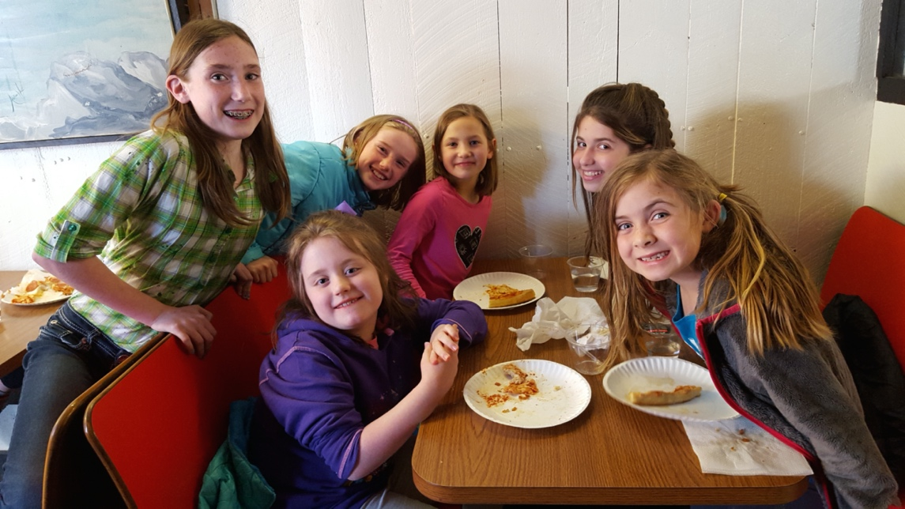

The CORSE Foundation has been chosen as the WBZ Cares feature charity for the month of March.

