http://www.bostonglobe.com/metro/regionals/south/2014/01/19/scituate-autism-group-thankful-for-flutie-foundation/I5OQ2c3ZAJyks3RvAK682H/story.html

Autism group thankful for Flutie Foundation
By Paul E. Kandarian | JANUARY 19, 2014

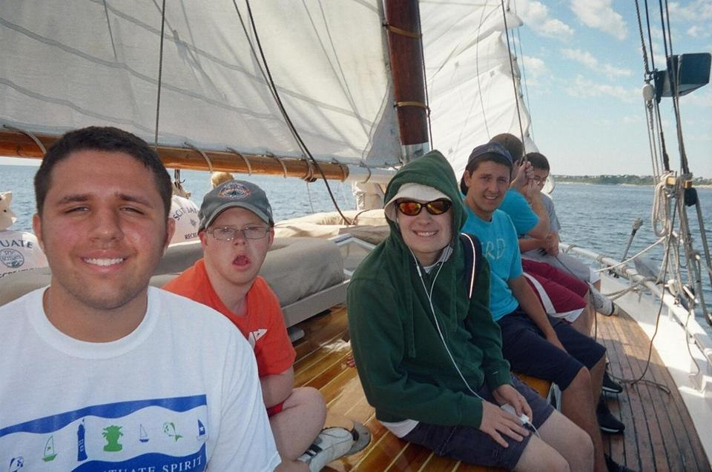

Youths and staff members go on a sailing trip as part of the Community of Resources for Special Education program in Scituate last summer.

BOWLING FOR CHARITY: Tracy Johnston of Scituate knows the challenges of having an autistic child and the benefit of programs that help him and others. As president of the nonprofit, Scituate-based Community of Resources for Special Education, which she and Marynell Henry founded in 2006, Johnston also knows the challenges of raising money to fund the 60 programs the group runs every year.
And though she has never met former football star Doug Flutie, Johnston greatly appreciates the Doug Flutie Jr. Foundation for Autism’s assistance to her group, which since 2009 has totaled $11,000.
To fund programs like CORSE, the 11th annual Flutie Bowl will be held Jan. 28 from 6 to 10 p.m. at the Kings bowling alley at Legacy Place in Dedham. Flutie and other celebrity bowlers will be on hand for the event, which since its inception has raised more than $600,000 for the foundation that Flutie and his wife, Laurie, established in honor of their son, Doug Flutie Jr., who was diagnosed with autism at age 3.
“His foundation was one of the first to support us,” Johnston said in a phone interview. “They’ve increased grants to us every year, and that’s critical in not just keeping our base-line programming, but giving us the chance to improve our offerings and expand on them.”

CORSE is run year-round, and has an annual budget of about $100,000, she said. It is an unusual organization, Johnston said, in that it serves children with and without special needs. Roughly two-thirds of the children, ages 3 to 22, are on the autism spectrum, and they are integrated into recreational programs with children who do not have special needs.
“Just about every child with special needs or their parents doesn’t want it to be just that, they want them interacting like their neighbors or peers in class,” Johnston said. “The goal of our program is to get as much integration as possible, so the kids can access the same types of programming as kids their age are accessing.”
In 2011, CORSE earned a Massachusetts Recreation and Park Association Program Outreach Award.

Johnston said her 12-year-old son, Billy, has been helped enormously by CORSE, which models its programming after that in the Scituate Recreation Department. In addition to sports, programs include music, horseback riding, academics, and peer mentoring.
“I may take for granted how Billy has benefited from it,” she said. “But three of the students in the program, including Billy, have made the swim team at the Recreation Department.
“We could not have come this far without the Flutie Foundation,” said Johnston, who with Henry received the Scituate Citizen of the Year award in 2009. “We’re not a large organization, but they understand what we do is important.”
For information on the Flutie fund-raiser, visit www.flutiefoundation.org.

