Scituate: Coach to be honored at gala event
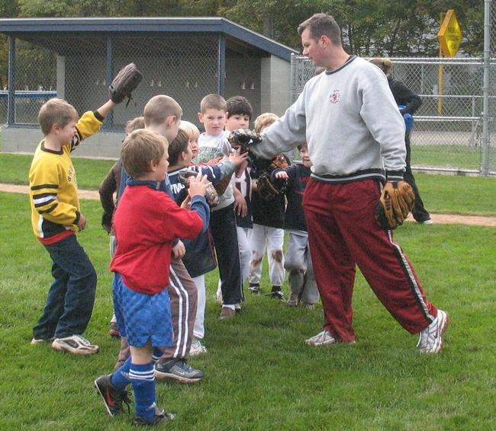

Mike "Coach Mike" Connor on the field with some of the kids in the CORSE program. Courtesy photo

By Ruth Thompson
rthompson@wickedlocal.com Posted Oct. 22, 2014 SCITUATE

The right coaching helps kids shine.

This is something the Scituate CORSE (Community of Resources for Special Education) Foundation understands and appreciates. The organization, which offers community-based programs for children with special needs, is even including these words in the theme of its 2014 All-Star Celebration Gala, taking place Saturday, Oct. 25 at the Scituate Country Club. And who better to honor during this event than Mike "Coach Mike" Connor, a coach who many people believe truly helps to make kids shine.

Connor will be receiving the CORSE Compass Award at the gala, the ninth such event for the organization. Tracy Johnston, president of the Scituate CORSE Foundation, said the award is to honor a member or members of the community who leads by example in demonstrating a commitment and compassion to children with special needs and their families.
"It was a natural fit for him to excel in our customized programming," she said, adding that Connor is a proven role model for kids. "He is our All-Star Coach that we depend on greatly."

Johnston said Connor was one of the organization’s original coaches for its recreation programs. "Without his innate ability to work with kids of all abilities and have them maximize their full potential in each program, CORSE would not have gotten such positive accolades from the community overall, and this launched us into a very successful recreation provider that serves kids with and without special needs," she said.

Originally from Quincy – his wife, he said, is a "townie" – Connor said he became involved with CORSE nine years ago after Jen Vitelli, of Scituate Recreation, asked him to run some sports camps. He met with Johnston and Marynell Henry, the co-founders of CORSE, to plan out how to run the pilot recreation programs for CORSE, which works hand-in-hand with Scituate Recreation.

"And I have worked with these great kids ever since," he said. The kids think Connor is pretty great as well. Johnston said he has "many fans throughout Scituate." "Coach Mike has had such a positive influence in my life," said Owen Concannon, one of the kids in the CORSE program. "What a great guy! Coach Mike has touched so many lives and uses his position of power for the greater good of others."
Owen’s mom, Julie, said her family "is forever grateful to Coach Mike."
"He has always been there for our family," she said.

A teacher by profession, Connor is currently the assistant principal at North Quincy High School. He said he has coached high school sports for the past 15 years, and that he continues to coach a variety of youth teams in Scituate. He has run the sports camps and the All-Star summer camps for CORSE.

Johnston said Coach Mike developed a special connection with each child and each family. "Mike treats every kid as an equal athlete, having high expectations of what each can do," Johnston said. "It is hard to find that balance of high coaching expectations while creating an environment where all the kids are having the time of their life."
Sue Campbell, the mother of a CORSE participant, recalled that, quite awhile back in All-Stars Basketball, "Coach Mike was teaching the kids defense and kept telling them 'get your hands up, keep your hands up,' and the next thing you know he starts swinging his hips waving his arms over his head and breaks into his best Miley (Cyrus) impersonation, and you hear Coach Mike singing, 'hands up, they're playing my song and the butterflies fly away.'"
"Trust me, it was hysterical," Campbell said. "He’s great. I’m so happy he’s being recognized."

The annual gala, Johnston explained, is a highly anticipated event and was the first original fundraiser that CORSE ran back in 2006. "It was such a tremendous success with such an outpouring of support from the community that it is one of our key sources for funds to run our 50 social, academic and recreational programs each year," she said. "We have just as many families, if not more, of children with no special needs attend, which is a huge testament to our community."
The night consists of dinner, live and silent auctions, and dancing. This year the band, The Gathering, will be performing.

Johnston said the gala is a sell-out or near sell-out every year.
"We are so grateful to the people who come to the event, as well as those who generously donate auction items," she said.
Connor said he would like to thank "this great community for the support of this organization and the amazing individuals who run CORSE." He said he has enjoyed the connections he has made with the youth he has worked with through CORSE, and that he definitely feels an organization like CORSE "betters all individuals involved – the staff, volunteers, parents and kids."

"That is what life is all about, helping others," he said. As for being recognized at the gala, Connor said, "I wish all the kids I have worked with could be there with me. They are the ones who deserve to be honored."

For more information on the CORSE gala, as well as the programs that are offered, visit www.corsefoundation.org.

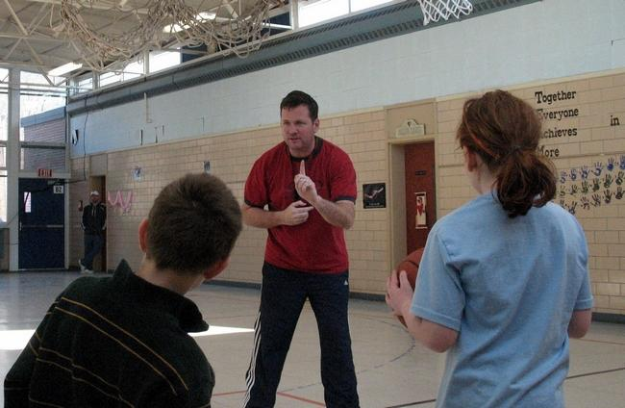
Coach Mike enjoyed meeting the kids he coached through CORSE. Courtesy photo

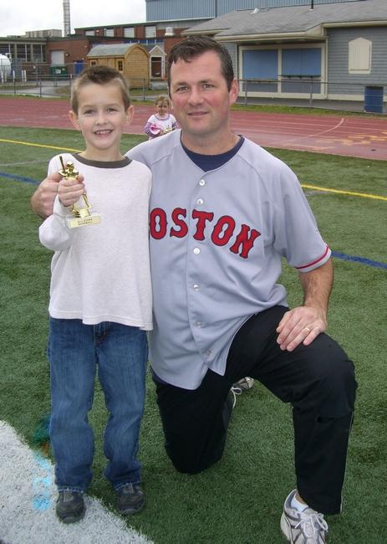
Mike Connor took pride in coaching kids of all athletic levels. Courtesy photo

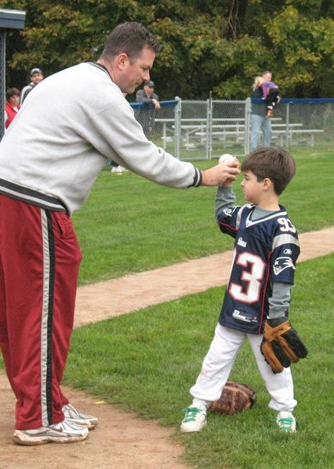
Coach Mike brought out the best in each child and treated everyone like an athlete. Courtesy photo

Facebook post with Article

Mike Connor you are the BEST!! Working with you is not work! Our Department and entire Scituate Community are truly blessed to have you. I remember like it was yesterday sitting down with you, Tracy Johnston & Marynell Henry planning the FIRST "All Stars" program and now under your leadership we are offering YEAR ROUND All Stars' programs and 3 summer camps!! You have truly helped shape a community, inspired future "All Star" staff and most importantly let children SHINE, & THRIVE ; children who might otherwise never had the opportunity to play on a team, to shoot a hoop; run the bases; play dodgeball, etc...(not to mention how incredibly happy & proud you have made their parents of them ) We all owe you a debt of gratitude. I can hear you now, "oh, Jen, please..its nothing" but oh it is something...something VERY big....Thank you, thank you, thank you!!!

