CORSE stays on track helping all children
By Ruth Thompson
rthompson@wickedlocal.com

Posted Jun 8, 2018 at 8:00 AM

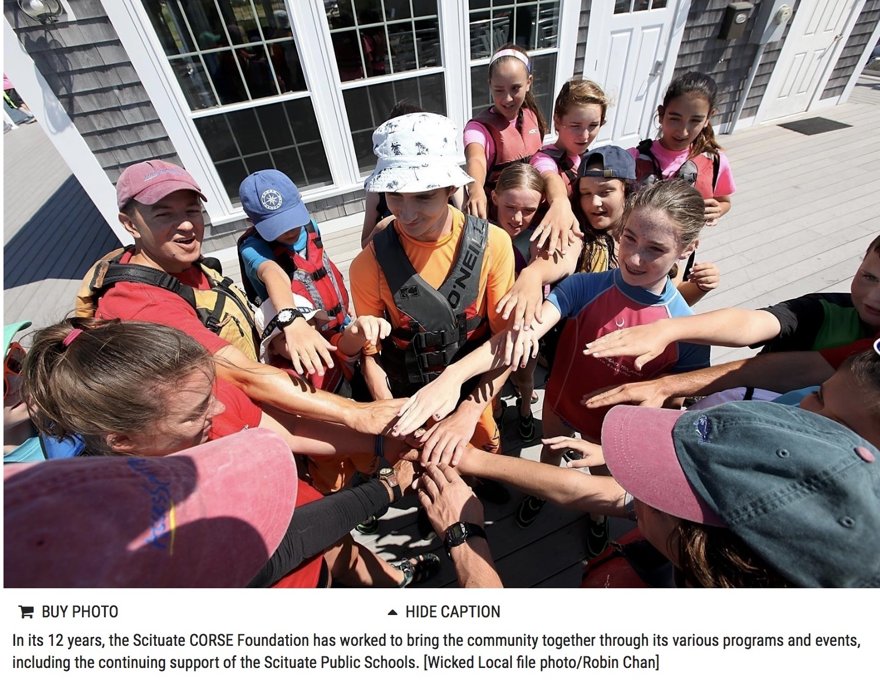

The Scituate Community of Resources for Special Education Foundation is best known for its integrated social programs for all children, with and without special needs, across the South Shore. In addition, the 12-year-old non-profit organization provides many more resources to the Scituate Public Schools.

“When our budgets close on June 30, we will have given Scituate Public Schools $104,100 this year, covering funding from the summer of 2017 through Academic Year 2017-18,” said CORSE President Tracy Johnston. “We also provided over $40,000 in recreation programming for our community as well this year.”

Over the past 12 years, CORSE has invested over $1.1 million in the community through 549 programs, 7,647 registrations and 1,050 student mentors. Annually, the organization runs approximately 60 programs for more than 1,000 students.

For Scituate Public Schools, CORSE provides music therapy, yoga, a band consultant for the Gates Band, Sibshops, high school scholarships, summer stipends for iExcel students, staff and parent workshops and social thinking curriculum for all schools in the district. Equipment purchases have included adaptive PE equipment, rock climbing walls and flexible classroom seating. The organization has also provided technology supports such as classroom amplification system, Lexia, Voice Thread, Brain Pop, and Read Naturally.

“We serve children in the district from age 3 to 22,” Johnston said. “It is very important to our board that we equitably distribute our funds and programming opportunities across all schools and grade levels in the district, from the Early Childhood Center through high school, including the iExcel post grad students. We want to assure inclusive programming to reach as many students in the district as possible.”

One of the most popular programs is Best Buddies, which Johnston said has grown tremendously over the past five years.

“Our high school and middle school models each have 100 students who participate annually,” she said. “We have expanded this model to younger elementary programs which sell out each year. We believe the appeal of these programs is based on the fact that there is no label of who are the ‘mentors’ and who are the ‘mentees.’ All students participate alongside each other and learn from each other. So many of our typically developing participants state that CORSE programming has been the ‘best experience’ of their lives and have fundamentally forever changed their perception of people with disabilities and their own sense of community.”

CORSE will be continuing all of its programming and resources during the next fiscal year with the addition of a few new programs and one enhanced program.

“This summer, we launched a pilot summer internship program with Scituate Recreation and we are bringing back the very famous iCan Bike program in August to teach children with special needs how to ride a two-wheeler independently,” Johnston said. “This is another chance for our entire community to come together since we have 60 community volunteers, mostly high school students, help make this life-changing program so successful.”

The organization will be making some enhancements to its academic support programs for Academic Year 2018-19 to center more on direct homework and skill-building support for student math and reading assignments.

“When we started CORSE 12 years ago, I don’t think anyone ever imagined the significant impact and investment we would be able to make for so many children,” Johnston said. “CORSE is successful because of the people in this community. I believe CORSE is one of the finest examples of the Scituate community coming together to collaborate. People from all backgrounds and abilities have worked together to create something so unique for our children, and in the process have built a more understanding and accepting community culture.”

Though CORSE started as a foundation focused on supplementing services for children with special needs, Johnston believes the community has grown so much stronger now that its mission has progressed to provide integrated programming where children of all abilities participate together.

Superintendent Ron Griffin said Scituate Public Schools are fortunate to have CORSE as a partner.

“Tracy Johnston and the entire CORSE organization are committed to providing students and families with enriching, innovative experiences that meet the unique needs of each child,” he said. “It’s been wonderful working with them and I’m looking forward to continuing and expanding that partnership in the future.”

Johnston said CORSE deeply appreciates the support of the Scituate Public Schools administration and all of the teachers, paraprofessionals, office staff and custodians in helping to facilitate CORSE along the way.

“We could not have accomplished what we have without their support, along with such a tremendous parent volunteer support base,” she said. “CORSE is a model that successfully demonstrates how parents, educators and community members can come together to build something so impactful for our students. Many of the take-aways of CORSE programs go well beyond skill development - it is making all children better individuals.”

For more information on the Scituate CORSE Foundation visit www.corsefoundation.org

