AccesSportAmerica program, a splash for special needs kids, “builds their confidence”
Posted Jul 25, 2018 at 3:23 PM
By Mary Whitfill
The Patriot Ledger
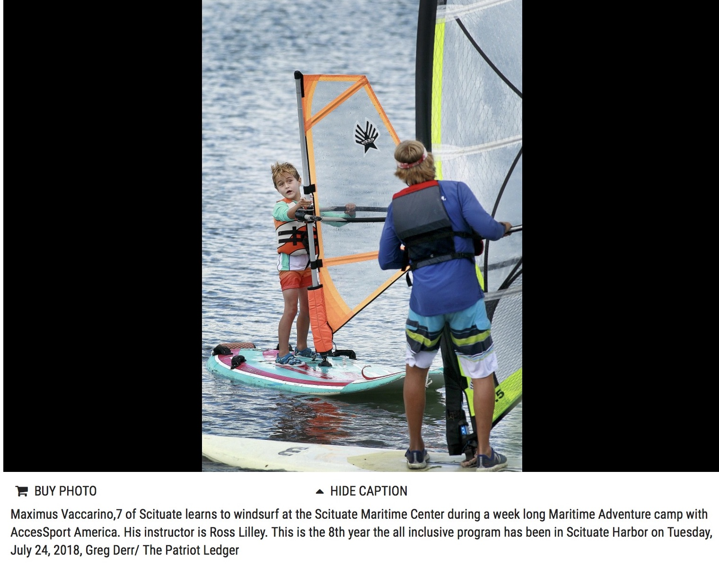
SCITUATE — Special needs aren’t getting in the way of outdoor activities for kids this summer thanks to an AccesSportAmerica maritime camp in Scituate that serves children with all types of disabilities.
Windsurfing, Hawaiian outrigger canoeing, sailing and stand-up paddling are all within reach at this camp, which runs for two weeks at Marine Park on Edward Foster Road. This is the seventh year the organization, alongside the Community of Resources for Special Education, has run a camp with the Scituate Recreation Department.
“It allows them to participate in a recreational water program; it makes them comfortable on the ocean with water sports, and it builds their confidence that they really can do something,” said Amy Pischel, chairwoman of the resource group.
The Maritime Adventures Camp is fully integrated, serving those both with and without special needs. Fifty percent of camp slots are reserved for those who need extra help, and AccesSportAmerica provides specialized instructors and equipment to make activities accessible to all. The other 50 percent of participants are typically developing children ages 6 to 18.
“You see a lot of these kids who look at a paddle board at the beginning of the week and are kind of conditioned to think ‘Oh, I can’t do that,’” Pischel said. “By the end of the week they’re standing up and you see this giant smile on their faces. You can see them blossom throughout the week and that’s really our goal – to provide a safe environment for them to grow and try new things.”
AccesSportAmerica is an Acton-based nonprofit that works to make sports and athletic training more available to people of all ages living with disabilities. The Scituate CORSE Foundation charges registration fees comparable to those for other summer camps, even though the program costs more because of the need for specialized staffing.
AccesSportAmerica also runs summer camps at Reservoir Pond in Canton and at two locations in Boston.

