- North Pole Express takes off from Scituate
Posted Dec. 18, 2015
The North Pole Express left the station Sunday, December 13 with crowds aboard each of the event’s four train rides. The annual event, which brings to life the scenes and story of “The Polar Express” raises money for two Scituate non-profit groups, the Scituate CORSE Foundation (Community of Resources for Special Education) and SHORE (Scituate High Opportunities and Resources for Education). The groups sold out with 2,700 tickets to ride.

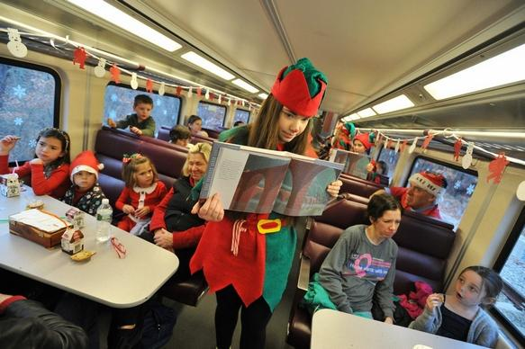
"Elf" Hope Yonce shows illustrations during the Polar Express story. Wicked Local photo/Tom Gorman

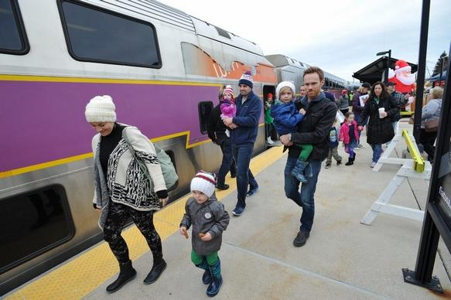

Families make their way onto the Polar Express train at the Scituate Greenbush station. 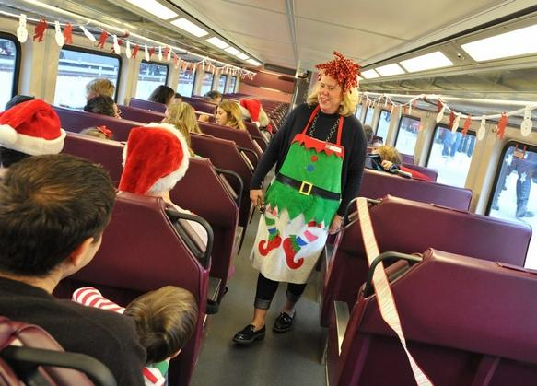
Clee McCarry greets passengers on the Polar Express.

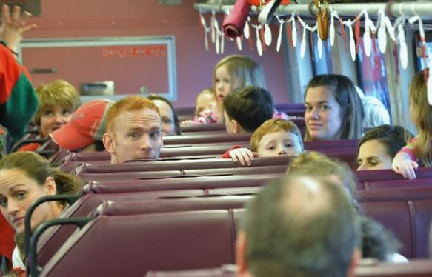
Adults and youngsters look for Santa. Wicked Local photo/Tom Gorman

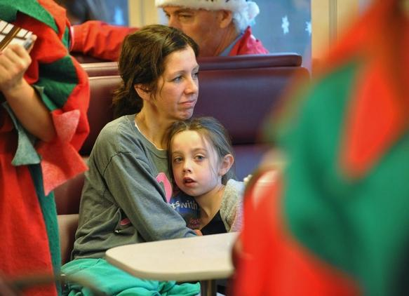
Kim Curtin and her daughter, Molly, 6, of East Bridgewater, relax during the Polar Express train ride. Wicked Local photo/Tom Gorman

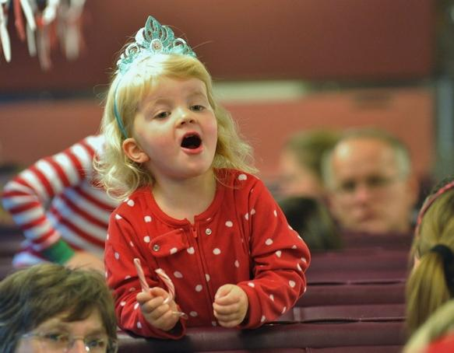
Vivien Koch, 3, of Cohasset, reacts when she spots Santa on The Polar Express. Wicked Local photo/Tom Gorman

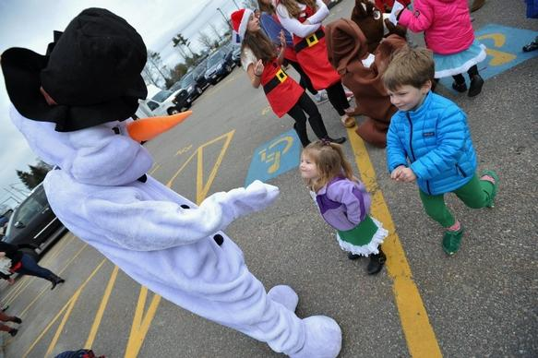

Makenna Arbour, 2, and her brother Hunter, 5, of Milton, say hello to Frosty before boarding the Polar Express. Wicked Local photo/Tom Gorman

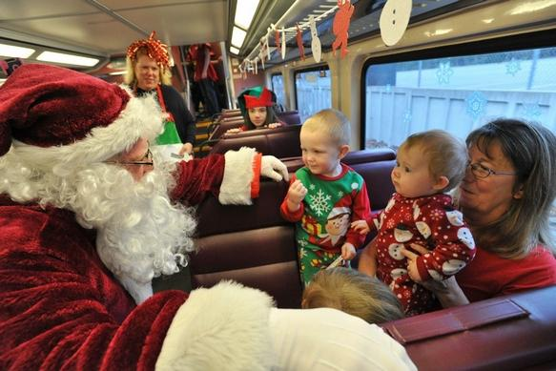

Santa greets the Robinsons, Bryce, 2, Rylie, 8, and grandmother Tammy of Marshfield as they ride the North Pole Express out of Scituate on Sunday, Dec. 13. Wicked Local photo/Tom Gorman

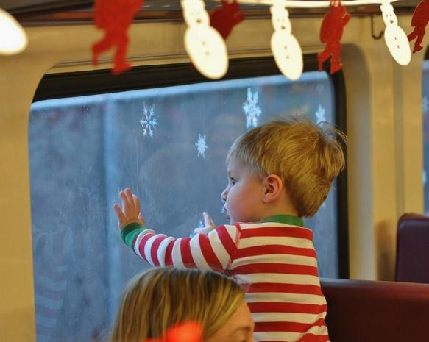

Sam Kuperstein, 20-mos., of Hingham, checks out the scenery on the Polar Express train. Wicked Local photo/Tom Gorman

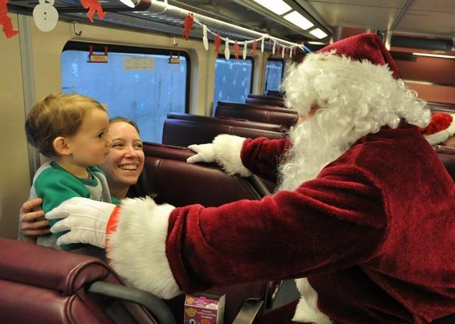

Ian Lis, 21-mos. and his mom, Heather, of Braintree, are greeted by Santa on the Polar Express train. Wicked Local photo/Tom Gorman

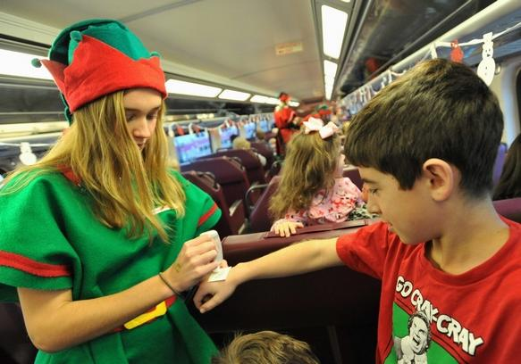

"Elf" Avery Carriuolo gives Michael Renna of Hingham a Christmas tattoo. Wicked Local Photo/Tom Gorman

