CORSE celebrates decade of helping children
Posted Feb. 20, 2016 at 11:19 AM SCITUATE

In honor of CORSE’s 10th anniversary, co-founder Tracy Johnston spoke to the Mariner about the value of the organization and its milestone.

What is CORSE?
CORSE (Community of Resources for Special Education) started with a vision of two people (Marynell Henry and Tracy Johnston), in January 2006. It was incorporated as a non-profit on Feb. 14, 2006 and has now grown to a board of 15 and a member constituency of more than 3,000 participants, all volunteers, representing parents of children with special needs, parents who have all typically developing children, educators and community members.
While we primarily serve Scituate, our programs do reach out to serve children in Weymouth, Hanover, Rockland, Whitman, Norwell, Hingham, Cohasset, Marshfield, Plymouth and Hull.
What’s it mean to see CORSE turn 10?
Speaking for myself and the CORSE Board, it is so fulfilling to be part of something that continues to have such a strong presence and impact for our community. People have been still enthusiastically supporting CORSE as strongly as ever, through volunteering and attending fundraisers over 10 years.
I remember Marynell and I sitting with Nancy Verseckes, director of special education then at Scituate Public Schools as well as Jennifer Vitelli, director of Scituate Recreation in 2006, discussing how to go about helping children with special needs meet their full potential as well as integrate them more into our community.
I don’t think anyone would have envisioned how CORSE would be so fully embraced by this community and how strong of an organization it would become. We are truly the finest example I have seen of collaborative programming spearheaded and designed by parents and educators that have provided such an important resource for our all our community’s children.
What value does CORSE have in the community?
Once feeling very isolated, families of children with special needs now have access to the same type of programming that their neighbor does—it has brought families together, to be more accepting of children’s differences in the community.
Families have a network to develop friendships, for the parents and the children. One mom said, “My child now has play-dates,” an incredibly huge statement if you have a child with special needs…
Our community has grown tremendously closer. Our program mentors and volunteers, many of them middle and high school students, state that being a part of CORSE programming has been the “best experience” of their lives and have fundamentally forever changed their perception of people with disabilities and their own sense of community.
How has the organization changed over the decade?
CORSE initially was established to provide supplemental programs, training and resources to help students with special needs reach their full potential. Usually, children with special needs cannot access regular community programs, making their options limited, and many were just sitting at home afterschool and on weekends. As we designed programs with SPS and Scituate Recreation, we quickly learned that children with special needs do not want to take programs exclusively for children with special needs, but want to take a program alongside their friends and neighbors. They just want to be a part of their community. Thus, we focused our efforts on developing integrated programs that were staffed appropriately through customized staffing ratios and special education expertise so all children, those with and without special needs, could successfully participate together within their community.
What's your favorite part about the organization?
When I can visibly see a child with special needs flourish from their experiences in CORSE programs, and their parents tell me they are mastering skills, sports or expanding friendships that they never thought possible, I know we are all contributing as a community to something so very meaningful and perhaps life-changing for families.
Final thoughts:
The success of CORSE is a reflection of your support, so these accomplishments are shared with you all.
By The Numbers

- 775,000, Amount (in dollars) CORSE has committed to the community.
- 100,000, Amount (in dollars) the organization budgets annually to run 40 programs with 700 student registrations, and provide $8,500 to families for financial or accessibility assistance to attend CORSE programs.
- 4,330, Number of student registrations over the decade.
- 871, Number of student mentors involved with the organization.

Compiled by Kristi Funderburk. Contact her at kfunderburk@wickedlocal.com.

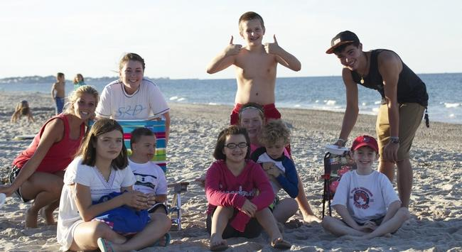
CORSE kids enjoy a day at the beach. Courtesy Photo

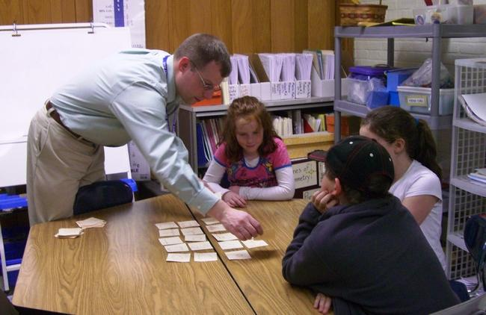
Students practice math during a 2008 program. Courtesy Photo

- From Scituate High School sporting events to Boston day trips, CORSE offers a variety of fun activities for local kids. Courtesy Photo

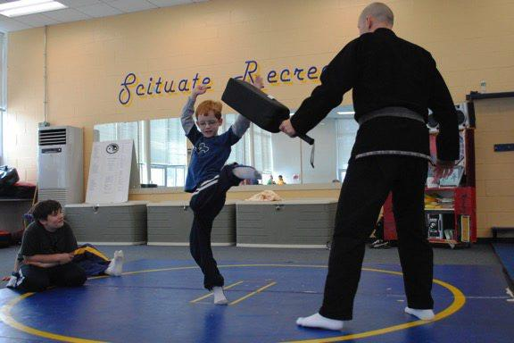

CORSE worked with various groups, including Scituate Recreation, to plan activities, such as karate. Courtesy Photo

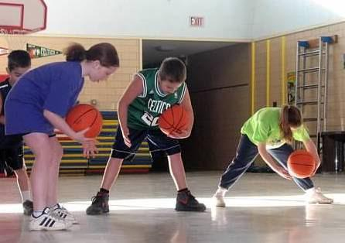
CORSE kids practice dribbling during the basketball program. Courtesy Photo

http://scituate.wickedlocal.com/article/20160220/NEWS/160229912/?Start=1

