A Foundation of fun for everyone

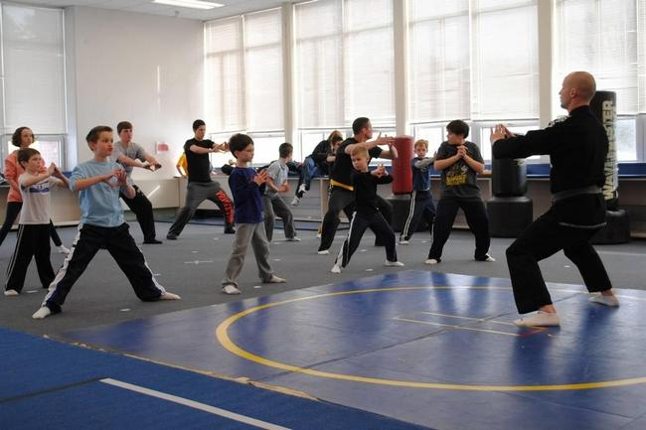
Kids participate in the All Stars Karate program through the CORSE Foundation. Courtesy photo

By Ruth Thompson rthompson@wickedlocal.com
Posted Oct. 5, 2015 at 11:13 AM SCITUATE
Peter Gates wanted to make sure his special needs son, Zachary, now 9, was provided the opportunity to participate in activities within the community, so Gates became involved with the Scituate Community of Resources for Special Education Foundation.

For 10 years, the CORSE Foundation has worked to fill the void in community-based programming for children with special needs. If offers programs for all children regardless of ability, and staffs them appropriately so children with special needs can access them.

The success of CORSE is a reflection of the people who live here, said Tracy Johnston, co-founder and president of the Scituate CORSE Foundation.
“I am not only proud of what CORSE itself has accomplished over the last 10 years with 322 programs, 4,120 student registrations and 861 mentors, but I am overwhelmed by the support of this community for our mission—to integrate and provide the same social, educational and recreational opportunities so children with special needs can participate along side their friends and neighbors,” she said.

The Special Education Department of the Scituate Public Schools works very closely with the CORSE Foundation. “The CORSE Foundation has supported programming for our students, both with and without special needs,” said Dianna Mullen, director of special education. “Some examples would be the funding of the Best Buddies Programs at the middle and high schools as well as starting up a club at the elementary level this year. They have supported funding and providers for programs such as yoga and music therapy in our self-contained program classrooms and in Early Childhood Center.”

Additionally, the CORSE Foundation provides opportunities for teachers and administrators to apply for grants to fund materials, as well as programming for students, and professional development opportunities for educators, Mullen said.

“The ways in which the CORSE Foundation supports our students and educators is so vast, and so appreciated by all educators and administrators of the Scituate Public Schools,” she said.
School Superintendent John McCarthy agreed.
“The Scituate Public Schools has an excellent special education program,” he said. “We strongly believe that, wherever and whenever possible, children with special needs are fully included and educated in their home town. Being able to “keep our kids home” requires us to continuously think outside the box and look for partners and resources. CORSE is an invaluable partner in our quest to fully live our mission. Without them, much of what we have built in our schools and community would never have happened.”

Over the course of his 30 plus years in education, McCarthy said he has encountered many community organizations that raised funds and supported educational programming that could not be adequately funded by the school budget.

“However, I have never experienced a program with the mission and passion for ensuring equity of access for children with special needs like CORSE,” he said. CORSE is not just a fundraising organization, McCarthy continued, but rather an educational organization destined to raise awareness in this community and beyond that all children have special gifts and talents and have a right to access everything any other child would.
“Whether it’s educational, social or recreational, CORSE supports high quality and sustainable programming throughout the school year and summer.”

Gates came to enjoy the organization so much he has spent about seven years on the board of directors, and pitches in with programs. Most recently he was the coordinator for the iCan Bike Camp held in August, which provided the opportunity for children with special needs learn to ride a bicycle independently.
“I enjoy being able to directly impact children and families in the community,” Gates said, adding that CORSE is vital to the community.

Mariah Avallone finds value in CORSE through her two daughters.
“Athena is 15, a special needs kid with autism, and she has participated in CORSE programming since the Foundation's inception 10 years ago,” Avallone said. “My 13 year old, Aurora, has also participated in CORSE programming for the last 10 years as a peer mentor and role model. So I am the proud parent of two of the original CORSE kids.”

Avallone believed so much in CORSE’s commitment and compassion to children with special needs and their families that she said she wanted to help, and became a volunteer a decade ago with the annual fundraising events.

“I try to help in any way I can and have been called upon to speak on behalf of CORSE from a parent's perspective,” she said. “This year I wrote a nomination application for the Myra Kraft Community MVP Awards that detailed CORSE's mission, and Tracy Johnston's dedication to our kids and her leadership in our community. I was so thrilled for Tracy when her efforts were recognized and she was named an award winner and CORSE received $10,000 from the New England Patriots Charitable Foundation to continue helping our kids.” Avallone is this year’s Compass Award Winner. The award is given to a member of the community who leads by example and has demonstrated a commitment and compassion to children with special needs and their families. This award is given out at organization’s annual Gala.

Jen Vitelli, co-director of the Scituate Recreation Department and a previous Compass Award winner, has always had the hope to have true integrated recreational programming. “The dream came true with the CORSE Foundation 10 years ago,” she said. “The recreation department’s partnership with the CORSE Foundation is undoubtedly the proudest, and in my opinion, the most important collaboration we have made.”
To see the smiles not only on the children’s faces, but also on the faces of the parents and grandparents who participate in the All Stars programs is absolutely priceless, Vitelli said.

The benefits of CORSE go beyond recreation, she added.
“It’s creating memories, eliminating loneliness, promoting sensitivity to individual’s differences, building strong bodies and minds, teaching vital life skills, forming friendships, and most importantly, instilling self-confidence,” she said.

Avallone credits CORSE with changing her daughter, Athena’s, life by enabling her to achieve success that to many would be just ordinary milestones, but to mother and daughter are extraordinary. “First time on a team, first trip around the bases, first forward roll, first time on a bike or in a boat, first math problem mastered, first paragraph penned, first feeling she had made a friend—CORSE programming has provided all of these firsts to my daughter and so many others in our community,” she said.

CORSE provides amazing opportunities for children and families with special needs, Gates said. “Additionally, CORSE delivers programs where integration and inclusion allows for children of all abilities and needs to participate together," he said. "This element allows special needs children to interact directly with their typical peers. This model is mutually beneficial and ultimately an important component to the community as whole.”

So many people, those with and without special needs, have come together to be board members, volunteers, student participants, mentors and donors, Johnston said.
“Scituate has embraced CORSE, and I am forever grateful and appreciative of the kindness, compassion and character of the people within this community.”

For more information on the Scituate CORSE Foundation, visit www.corsefoundation.org or on Facebook under Scituate CORSE Foundation.

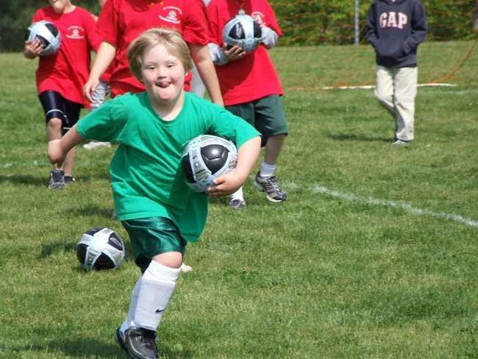
CORSE programs encourage sportsmanship, team playing, friendship and self-confidence. Courtesy photo

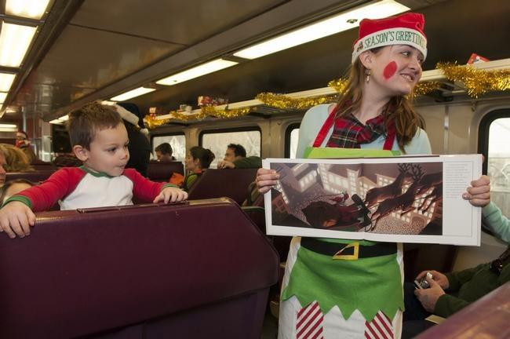
Dylan Barlow, 2, of Abington enjoys the pictures while listening to a reading of the "Polar Express" during CORSE's North Pole Express, a popular annual fundraiser. Wicked Local file photo

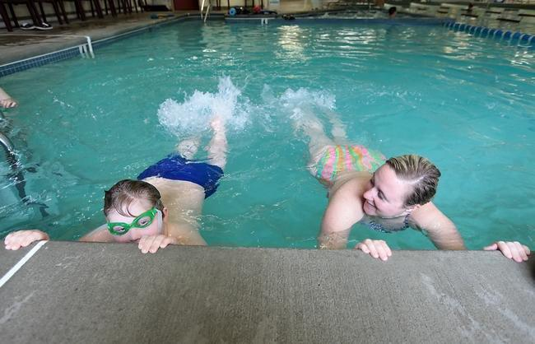
Lauren McGonagle of Marshfield shows Cole Cadigan, 10, of Scituate how to kick in the water while teaching him how to swim at the Healthtrax in Hanover on Saturday during the CORSE swimming class. The Patriot Ledger file photo

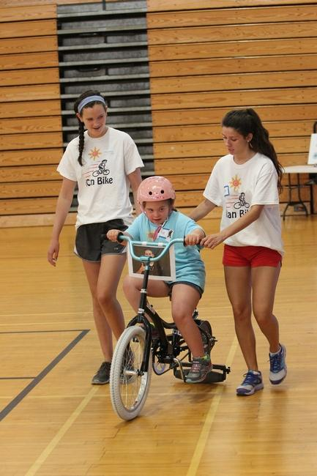
Volunteers Hanna Lydon, 15, of Scituate (left) and Sarah O'Donovan, 17, of Newton (right) run alongside as Ava McLaughjlin, 9, of Dorchester enjoys indepently riding a bike with the iCan Bike program sponsored by CORSE (Community Resorces for Special Education) from Aug. 10 to 14 at Scituate High School. Wicked Local Staff Photo/Chris Bernstein

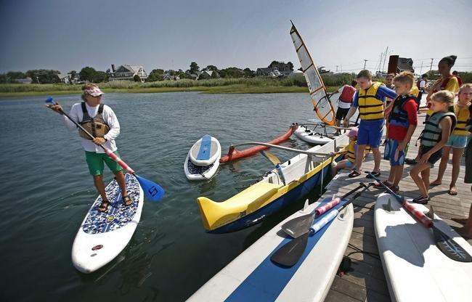
Ross Lilley, left, leads Maritime Adventures campers into the water on July 22 in Scituate. Participants in the program, an offering of AccesSport America and CORSE, got to try windsurfing, Hawaiian outrigger canoeing, sailing and stand-up paddleboarding. Greg Derr/The Patriot Ledger

