Scituate maritime camp offers adventure to special needs children
By Jessica Trufant
The Patriot Ledger
Posted Aug 09, 2013 @ 02:58 PM

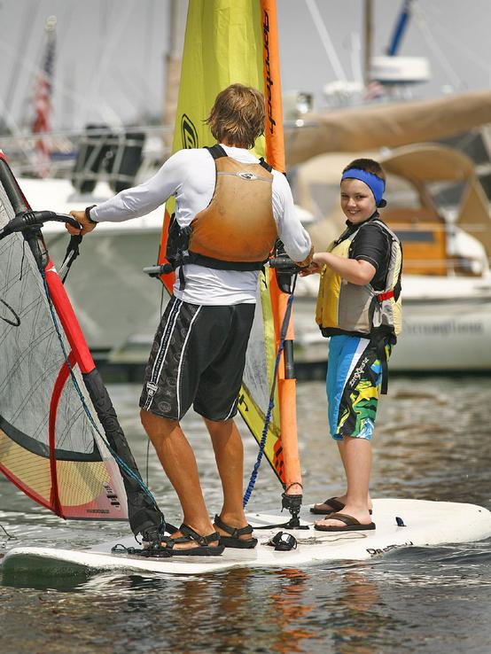
Greg Derr/The Patriot Ledger
Gavin Chaisson, 10, gets lessons on a tandem windsurfer with Ross Lilley as part of the CORSE program at the Scituate Maritime Center on Monday, July 22, 2013.

SCITUATE —
Standing on the dock in front of the Maritime Center in Scituate Harbor, Owen Baum of Norwell practiced using his nautical lingo. He yelled “Ahoy, matey!” to his friends, who drifted in on paddleboards and canoes.
Owen is among the dozens of children who have spent time this summer building skills in windsurfing, Hawaiian outrigger canoeing, sailing and stand-up paddleboarding in the Maritime Adventures camp, which is offered through AccesSport America and the Community of Resources for Special Education non-profit foundation.
“Windsurfing was the hardest part,” Owen, 12, said after more than an hour in the water. “I really liked the sailing part.”
Now in its fourth summer, the Maritime Adventures camp is an opportunity for South Shore children with special needs to experience the same summer activities that other children enjoy.
“We live in this beautiful beach town, and all the other kids do sailing camps and surfing camps, so we thought, ‘Wouldn’t it be great if we could offer a camp with the same opportunities and the expertise?’” said Tracy Johnston, who co-founded CORSE in 2006.
AccesSport America, an Acton-based nonprofit organization, allows communities to offer challenging fitness programs for children with disabilities.
“To see a child in a wheelchair up windsurfing is an incredible thing,” Johnston said. “Special-needs kids want to be like any other kids.”
To encourage integration, about 20 percent of children at the camp do not have special needs, and high school students volunteer to earn community-service hours.
Simon Halfond, 10, of Scituate made the peace sign with two fingers before leaping off his paddleboard into the water.
“I’m doing great,” Simon yelled at he bobbed in the water. “Swimming is always fun.”
Now in his second summer at the Maritime Adventure camp, Simon was quick to try the various water sports.
Asked if he thought any of the activities were difficult, Simon said, “Not at all. I’m experienced with this stuff.”
CORSE offers about a 100 programs for children ages 3 to 22 throughout the year. The program are paid for through registration fees, grants and fundraisers. For more information, visit www.corsefoundation.org.
Jessica Trufant may be reached at jtrufant@ledger.com.

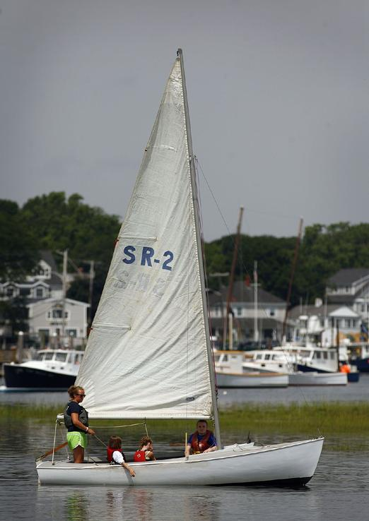

Greg Derr/The Patriot Ledger
Students in the CORSE program in Scituate take part in an on the water program" Access Sport America" at the Scituate Maritime Center on Monday, July 22, 2013.
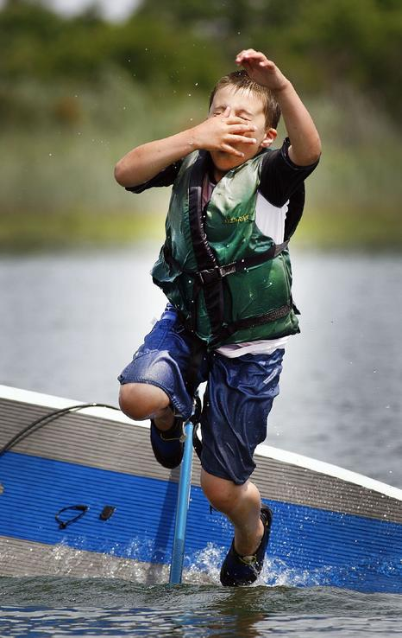

Ten-year old Simon Halfond jumps into Scituate Harbor to cool off after completing part of the CORSE program at the Scituate Maritime Center on Monday, July 22, 2013.

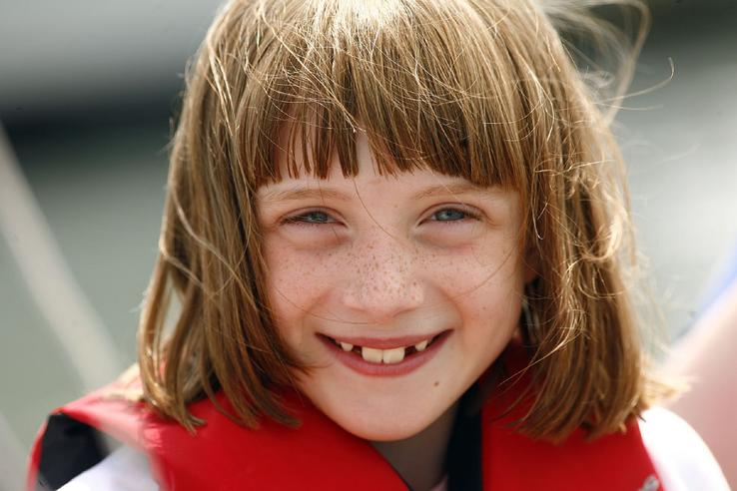
Greg Derr/The Patriot Ledger
Kara McLaughlin, 8, was among the participants in the CORSE program at the Scituate Maritime Center on Monday, July 22, 2013.

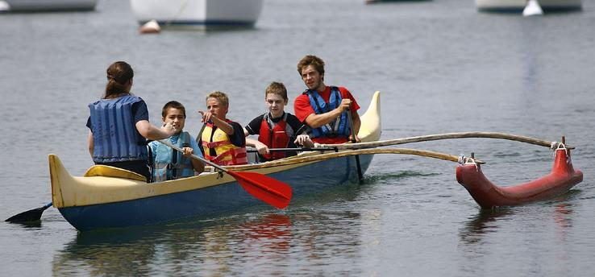
Greg Derr/The Patriot Ledger
Students paddle an outrigger canoe in Scituate Harbor during the CORSE program at the Scituate Maritime Center on Monday, July 22, 2013.

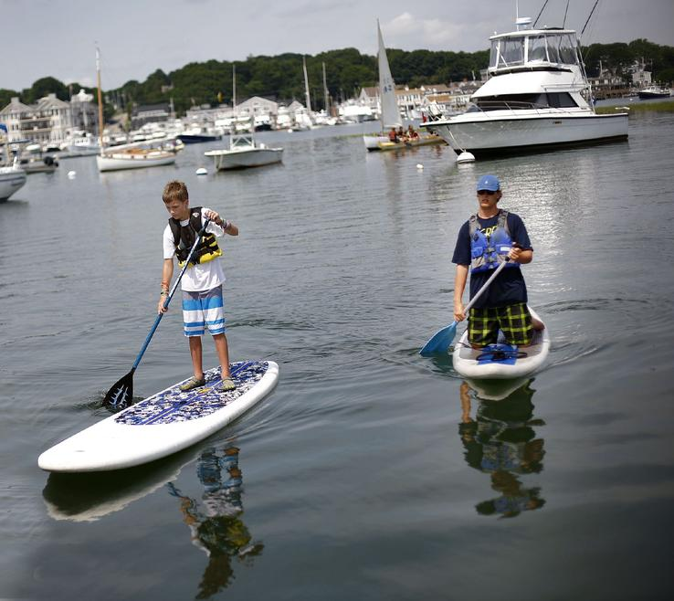
Greg Derr/The Patriot Ledger
Mike Glancy, right, works with Declan O'Neil,12, on the standup paddle board during the CORSE program at the Scituate Maritime Center on Monday, July 22, 2013.

